Table of Contents

FRONT PAGE

CERTIFICATION……………………………………………………………………………. I

DEDICATION………………………………………………………………………………… II

ACKNOWLEDGEMENT……………………………………………………………………. III

TABLE OF CONTENTS……………………………………………………………………… 5

ABSTRACT

CHAPTER 1 8

INTRODUCTION 8

1.1 A BRIEF OVERVIEW OF CIVIL ENGINEERING 8

1.1.1 HISTORY OF CIVIL ENGINEERING. 9

1.1.2 BRANCHES OF CIVIL ENGINEERING. 11

1.1.3 QUALITIES OF A CIVIL ENGINEER 16

1.1.4 TRAINING OF A CIVIL ENGINEER 17

1.1.5 FUNCTIONS OF A CIVIL ENGINEER 17

1.2 STUDENT INDUSTRIAL WORK EXPERIENCE SCHEME 18

1.2.1 HISTORY OF SIWES 19

1.2.2 OBJECTIVE OF SIWES 20

1.2.3 ADVENT OF SIWES 20

1.3 FIRM PROFILE OF ADVANCED ENGINEERING CONSULTANTS 21

1.3.1 SERVICES RENDERED BY ADVANCED ENGINEERING CONSULTANTS. 23

1.3.3 ORGANIZATIONAL CHART 24

CHAPTER 2 25

2.0 LITERATURE REVIEW 25

2.1.1 Building components. 26

2.1.2 FRAMED AND NON-FRAMED STRUCTURES. 27

2.2 REINFORCED CONCRETE 28

2.2.1 CONCRETE 30

2.2.2 STEEL REINFORCEMENT 37

2.3 DESIGN OF REINFORCED STRUCTURES 39

2.4 DESIGN PHILOSOPHY 42

2.5 THE DESIGN PROCESS 45

2.5.3 Structural Analysis 49

2.5.4 Structural Design 55

2.5.5 Detailing of Structural Members 56

2.5.6 Preparation of Bar Bending Schedule 58

2.6 ROAD DESIGN 60

2.6.1 Geometric Design of a road 61

2.6.2 SIGHT DISTANCE 61

2.6.3 HORIZONTAL ALIGNMENT 64

2.6.4 VERTICAL ALIGNMENT 71

CHAPTER 3 77

TECHNICAL EXPERIENCE 77

3.1 Reinforced Concrete design of a two storey Building Using Orion 77

CHAPTER 4 92

CHALLENGES ENCOUNTERED DURING SIWES 92

4.1 CHALLENGES ENCOUNTERED DURING THE PROGRAM. 92

CHAPTER 5 94

CONCLUSION AND RECOMMENDATIONS 94

5.1 CONCLUSION 94

5.2 RECOMMENDATIONS 94

REFERENCES

**ABSTRACT**

This report contains a summary of what I learnt during my six months’ Industrial attachment at Advanced Engineering Consultants, Ilupeju Lagos State. I was attached to the Structures and Heavy Civils Department as well as the Transportation and Highway department.

This Report entails relevant knowledge I was able to acquire during this period. I was involved in the design of reinforced structures manually and with the use of computer programs such as CSC Orion and Tedds for the modelling and design of reinforced concrete structures. I was also involved basic calculations in the design of roads and creating drawings using Civil 3D.

Structural drawings, Structural Calculations, Highway Drawings, Calculations and other relevant details I worked on are represented in this report as part of the experience I was able to gather.

# CHAPTER 1

## INTRODUCTION

## 1.1 A BRIEF OVERVIEW OF CIVIL ENGINEERING

Civil engineering is a professional engineering discipline that deals with the design, construction, and maintenance of the physical and naturally built environment, including public works such as roads, bridges, canals, dams, airports, sewerage systems, pipelines, structural components of buildings, and railways. It is considered the second-oldest engineering discipline after military engineering, and it is defined to distinguish non-military engineering from military engineering (Wikipedia, 2012).

Civil engineering deals with the planning, designing, construction and maintenance of buildings and various other structures. Design of all members of the structure along with precise specifications are drafted on drawing sheets prior to the construction process. Analysis of various forces that will act on each member of the structure is made and on the basis of that further modification in the design is done. Even the smallest corner of the planned structure is scrutinized to check the amount of stresses and strains that might arise when the structure is built or in the process of construction. Also, the structures are also provided with tolerance levels to adjust deviations due to wind, seismic activities, or natural calamities. These tolerances allow the building to resist the natural forces and thus stand firm without being affected negatively. Also, with a massive increase in awareness towards renewable sources of energy, Civil Engineering applications have also increased. Environmental engineering, a sub-branch of civil engineering ensures that structures have a minimal impact on the environmental balance and minimize carbon footprints that might occur during and after construction. Environmental engineering also deals with creating structures on both onshore and of shore sides in order to make efficient and environmentally friendly sources of energy. Some of these applications include various methods to purify the contaminated air and water, utilizing solar energy, generating fresh water, utilizing wind and water energy, and protecting the marine environment. Civil engineering is becoming more and more diversified with the increase of applications. Moreover, the guidelines of constructing structures have also become more stringent, stressing issues such as human safety and resistance to natural and man-made calamities.

The Influence of Civil engineering is relevant in the public sector from the local governments through to the national governments, and also in the private sector from individual homeowners, private business owners, through to international companies. Not only do civil engineers design systems that interact with one another, but they are also concerned with the overall environment’s well-being. Civil engineers apply the knowledge of physical and scientific principles to solve societal problems. The history of civil engineering is linked to advancement in the understanding of physics and mathematics among other physical science subjects throughout history. Because civil engineering is a wide-ranging profession, including several specialized sub-disciplines, its history is linked to knowledge of structures, materials science, geography, geology, soils, hydrology, environment, mechanics and other fields

## 1.1.1 HISTORY OF CIVIL ENGINEERING.

Civil engineering is often regarded as the oldest engineering discipline after military engineering. It is however difficult to really determine the history of the emergence of civil engineering. The history of civil engineering can as well be documented alongside the history of humans. Ever since man has existed on earth, he has always found the need to interact with the environment through creating shelter to keep himself against harsh climatic conditions and protection against other vices of the environment, he also created links in form of paths to move from one place to another through clearing of bushes to make paths and felling of tree trunks to cross rivers which sums up the demonstration of ancient age civil engineering.

Civil Engineering has been an aspect of life since the beginning of human existence. The earliest practices of Civil engineering may have commenced between 4000 and 2000 BC in Ancient Egypt and Mesopotamia when humans started to abandon a nomadic existence, thus causing a need for the construction of shelter. During this time, transportation became increasingly important leading to the development of the wheel and sailing.

According to historians, the Pyramids were constructed in Egypt during 2800-2400 BC and may be considered as the first large structure construction ever. Around 2550 BC, Imhotep, the first documented engineer, built a famous stepped pyramid for King Djoser located at Saqqara Necropolis in Egypt. With simple tools and mathematical understanding, he created a monument that stands to this present day. His greatest contribution to engineering was his discovery of the art of building with shaped stones.

Other ancient historic civil engineering constructions include the Qanat water management system (older than 3000 years and longer than 71 km,) and the Parthenon by Iktinos in ancient Greece (447-438 BC). The Romans developed civil structures throughout their empire, especially aqueducts, insulae, harbors, bridges, dams and roads. The Appian Way built by Roman engineers was an extensive system of highways the Romans built to facilitate trading and fast maneuvering of chariots. Julius Caesar's Bridge over the Rhine River built in 55 BC was among the numerous bridges built by the Romans. The Pont du Gard (Roman Aqueduct, Nimes, France) built in 19 BC; The Great Wall of China was built around 200 BC and is considered another achievement of ancient civil engineering. The Wall was designed by General Meng T’ien under orders from Ch’in Emperor Shih Huang Ti.

The Machu Picchu in Peru was built around 1450, at the height of the Inca Empire. It was also considered an engineering marvel. It was built in the Andes Mountains assisted by some of history’s most ingenious water resource engineers. The people of Machu Picchu built a mountain top city with running water, drainage systems, food production and stone structures so advanced that they were in place for over 500 years. A scientific approach to the physical sciences concerning civil engineering was implemented by Archimedes in the third century, by utilizing the Archimedes Principle concerning buoyancy and the Archimedes screw for raising water.

Other remarkable historical structures are Sennacherib's Aqueduct at Jerwan built in 691 BC; Li Ping's irrigation projects in China around 220 BC which was an extensive irrigation system constructed by the Hohokam Indians. The first dykes built to shield the hinterlands against high sea level in Friesland, Netherlands were developed around 1000 AD.

In the 18th century, the term civil engineering was formed to include all things civilian as opposed to military engineering. The first self-proclaimed civil engineer was John Smeaton, who constructed the Eddystone Lighthouse. In 1771 Smeaton and some of his colleagues formed the Smeatonian Society of Civil Engineers, a group of leaders of the profession who met informally over dinner. Though there was evidence of some technical meetings, it was little more than a social society.

In 1818 the Institution of Civil Engineers was founded in London, and in 1820 the eminent engineer Thomas Telford became its first president. The institution received a Royal Charter in 1828, formally recognizing civil engineering as a profession. Its charter defined civil engineering as: the art of directing the great sources of power in nature for the use and convenience of man, as the means of production and of traffic in states, both for external and internal trade, as applied in the construction of roads, bridges, aqueducts, canals, river navigation and docks for internal intercourse and exchange, and in the construction of ports, harbors, moles, breakwaters and lighthouses, and in the art of navigation by artificial power for the purposes of commerce, and in the construction and application of machinery, and in the drainage of cities and towns.

## 1.1.2 BRANCHES OF CIVIL ENGINEERING.

Civil Engineering is a broad engineering discipline with a number of sub-disciplines. Civil engineers are responsible for the building of bridges, roads, skyscrapers, canals, dams, and other such big structures. Civil engineering not only creates the environment we live in but improves and protects our lives. Civil engineers are responsible for sustainable energy, in this era of fast depleting fuel and resources, and even the supply of clean water; a world without them would be unimaginable. Civil engineering is one of the oldest branches of engineering and is further divided into numerous other sub-disciplines. The sub-disciplines are listed below with a brief description.

* Structural Engineering: This branch of civil engineering deals with the structural analysis and design of structures. The structural engineer does the analysis and design a structure that will safely bear or resist stresses, forces and loads imposed on it. The design produced by the structural engineer must satisfy the specifications while meeting all safety requirements. The structure must be able to bear massive loads as well as natural disasters and climate changes without failure detrimental to the lives of users and occupants of the structure.



Plate 1.0: Typical High Rise buildings designed by structural Engineers.

* Transportation Engineering: Civil engineers that work as transportation engineers will work in the planning, construction and management of transportation facilities. They deal with the design and implementation of the infrastructures that deal with transportation in order to provide safe, comfortable, convenient, economical and environmentally compatible mode of transports. Sub-divisions that are related to transportation engineering are highway, air transportation, waterway transportation, aerospace, coastal & ocean and urban transportation. The Major specialties in transportation engineering are;
* Traffic engineering, which focuses on the infrastructure necessary for transportation
* Highway engineering, which deals with major roadways and transportation systems involving automobiles. Highway engineering usually involves the construction and design of highways
* Railway systems engineering.



Plate 1.1: Highway interchanges.

* Water Resources Engineering: This aspect of civil engineering deals with the design and construction of hydraulic structures. Hydraulic structures include dams, canals and water distribution system. The water resources engineer is responsible for the design of the structure as well as the implementation and safety precautions that must be strictly followed. Major specialties concerned with water resources engineering include;
* Hydraulic engineering which is concerned with the flow and movement of fluids, principally water. Hydraulic engineering is intimately related to the design of pipelines, water supply network and drainage facilities (including bridges, dams, levees, channels, culverts, storm sewers), and canals.
* River engineering involves planned human intervention in the course, characteristics, and flow of a river with the intention of producing some defined benefit to manage water resources, to protect against flooding, or to make passage along or across rivers easier.
* Coastal engineering is the study of the processes ongoing at the shoreline and construction within the coastal zone, often directed at combating erosion of coasts or providing navigational access.
* Groundwater engineering is the process of analyzing, monitoring and sometimes modelling of a groundwater source to better understand how much remains and if the water can be used for various purposes.

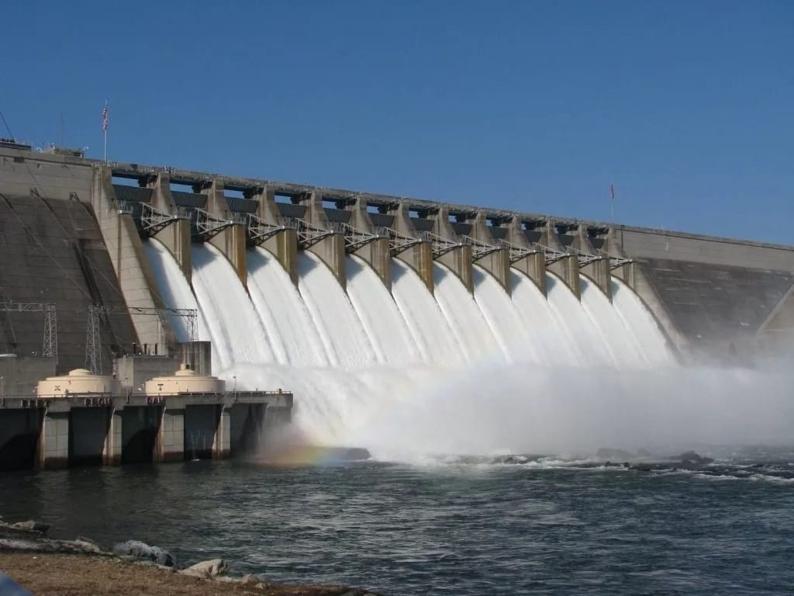

Plate 1.2: Kainji Dam, An Hydraulic Structure

* Construction Engineering: This branch of civil engineering deals with the planning, construction and maintenance of civil engineering structures. Construction engineering is the planning and execution of designs from site developers, environmental, structural, transportation and structural engineers. The construction engineers ensure that the plans designed by the design engineers are implemented to their exact specifications. Construction engineers supervise field work during the entire project. They are more like a link between an engineer and manager as they will oversee the project from start to finish and handle any problems that come up throughout the duration of the project.
* Geotechnical Engineering: Geotechnical engineering involves the study of soil, foundations, and their bearing capacities. The geotechnical engineer studies the behavior of earth materials and how they will affect a structure that is to be constructed. He also evaluates pre-existing structures that are showing signs of problems with the earth materials under or near the structure. Specific sub-aspects under geotechnical engineering include;
* Mining engineering, which is the exploration, extraction and processing of raw materials from the Earth
* Foundation engineering which is simply defined as the engineering of substructures that support superstructures.

Other branches of Civil Engineering are;

* Coastal Engineering
* Tunnel Engineering
* Environmental Engineering
* Earthquake Engineering
* Material Engineering
* Surveying
* Municipal Engineering

General civil engineers work closely with surveyors and specialized civil engineers to design grading, drainage, pavement, water supply, sewer service, dams, electric and communications supply. General civil engineering is also referred to as site engineering, a branch of civil engineering that primarily focuses on converting a tract of land from one usage to another. Site engineers spend time visiting project sites, meeting with stakeholders, and preparing construction plans. Civil engineers apply the principles of geotechnical engineering, structural engineering, environmental engineering, transportation engineering and construction engineering to residential, commercial, industrial and public works projects of all sizes and levels of construction.

## 1.1.3 QUALITIES OF A CIVIL ENGINEER

A Civil Engineer must possess the following qualities to be efficient in tasks given to him.

1. A Civil Engineer Must Possesses a Strong Analytical Aptitude: A civil engineer must possess excellent analytical skills and is continually examining things and thinking of ways to help things work better.
2. A Civil Engineer Must Show attention to Details: A civil engineer must pay meticulous attention to detail. The slightest error can cause an entire structure to fail, so every detail must be reviewed thoroughly during the course of completing a project.
3. A Civil Engineer Must have Excellent Communication Skills: A civil engineer must have a top notch communication skill. He must be able to translate complex technical terms into plain English and also communicate verbally with clients and other engineers working together on a project.
4. A Civil Engineer Must Take Part in Continuing Education: A civil engineer must stay on top of developments in the industry. Changes in technology happen rapidly, and the most successful civil engineers keep abreast of new research and ideas.
5. A Civil Engineer Must Be Creative: A civil engineer must be creative and can think of new and innovative ways to develop new systems and make existing things work more efficiently.
6. A Civil Engineer Must Show an Ability to Think Logically: A civil engineer must have top-notch logical skills. He must be able to make sense of complex systems and understand how things work and how problems arise.
7. A Civil Engineer Must Be Mathematically Inclined: A civil engineer must be excellent math skills. Engineering is an intricate science that involves complex calculations of varying difficulty.
8. A Civil Engineer Must Have Good Problem Solving Skills: A great engineer has sharp problem solving skills. A civil engineer will be frequently called upon solely to address problems, and he must be able to figure out where the problem stems from and quickly develop a solution.
9. A Civil Engineer Is a Team Player: A civil engineer understands that he is part of a larger team working together to make one project come together successfully, and therefore, must work well as part of that team.
10. A Civil Engineer Must Have Excellent Technical Knowledge: A civil engineer must have a vast amount of technical knowledge.

## 1.1.4 TRAINING OF A CIVIL ENGINEER

The civil engineering program at the undergraduate level in Nigeria is designed to train civil engineering students who will later become civil engineers who will be capable of design, analysis, construction and maintenance of physical facilities to be used in the society. To become a certified engineer, one must undergo the B.Sc. program in civil engineering in a Council for the Regulation of Engineering in Nigeria (COREN) certified University or obtain a Higher National Diploma Certificate (HND) in a Polytechnic in civil engineering and then sit for a graduates’ examination. This examination is conducted by the Nigerian Society of Engineers NSE, which is the umbrella organization for all engineering professions in Nigeria. The graduate engineer can become registered with Council for the Regulation of Engineering in Nigeria COREN after about 5 years of working experience. He then receives a license to practice engineering in Nigeria, and can be officially referred to as an Engineer.

## 1.1.5 FUNCTIONS OF A CIVIL ENGINEER

The functions of the civil engineer can be divided into three categories: those performed before construction (feasibility studies, site investigations, and design), those performed during construction (dealing with clients, consulting engineers, and contractors), and those performed after construction (maintenance and research) (Wikipedia, 2012).

## 1.2 STUDENT INDUSTRIAL WORK EXPERIENCE SCHEME

Students’ Industrial Work-experience Scheme (SIWES) is one of the Industrial Training Fund (ITF) program which was introduced in 1974 due to the inability of engineering and technology students in Nigeria universities and polytechnics to meet the practical aspects of their training. That is, the need to enable students compliment their theoretical school knowledge with the practical aspect of their training in the industry relevant to their course of study. This period of training is to last for six months.

According to Ekpenyong (2011), one of the principles underlying any industrial work experience scheme for students in institutions of learning is the desire to incorporate the practical with the theoretical learning which is characterized by conventional classroom situations with the objective of striking a balance between theory and practice. The author stressed further that it was in realization of this that the Industrial Training Fund (ITF) was established. The ITF was set out to study the extent to which the theoretical knowledge that students in engineering technology and other allied fields in Nigerian institutions offering technology based courses related to the kind of work experience expected of them by employers.

The result of the ITF survey showed a great disparity between students’ knowledge and their ability to apply it in relevant jobs. In order to bridge the gap between the two, the ITF in 1974 established a co-operative internship program, which enabled students of technology to spend some part of their courses for relevant on the-job practical experiences in appropriate areas of the Nigerian industry (Ekpenyong, 2011). The author further stressed that the internship program, SIWES, can therefore be seen as that which is intended to give Nigerian students studying occupationally related courses experience that would supplement their theoretical learning as a well of equipping the students with the needed skills to function in the world of work. This need to combine theoretical knowledge with practical skills in order to produce results in the form of goods and services or to be productive is the essence and rationale for industrial training, and a basic requirement for the award the engineering degree.

## 1.2.1 HISTORY OF SIWES

At the early stages of the development of education in Nigeria, there was a problem of the gap between theory and practical skills of students. Therefore, there was a need to give students the opportunity to get real work experience. The program was created to give students experience in addition to theoretical learning. The industrial training policy was introduced by Federal Government of Nigeria in 1973. This project was necessary to improve practical skills of students. SIWES has become a necessary pre-condition of graduation. The program is working with such disciplines as engineering, medical science, natural science, technology, agriculture, education, environmental, applied science. The duration of the program can be different, for the universities it's six months, and a year for college and polytechnics. The program is developed under the guidance of the Ministry of Education. This is an excellent bridge between theoretical and practical education. SIWES is working on designing proper programs for exposing students to the industrial workplace environment. It is all about the development of occupational competence.

The Students Industrial Work Experience Scheme (SIWES) was initiated in 1973 by the industrial training fund (ITF). This was in response to the mandate given to the ITF, through decree 47 of 1971, charging it with the responsibility of promoting and encouraging the acquisition of skills industry and commerce with the view to generating a pool of trained indigenous manpower sufficient to meet the needs of the economy since its introduction by the ITF in 1973, the scheme has gone through series of reforms and restructuring.

The 1988 biennial SIWES/ITF national conference held in Jos mandated all collaborating agencies National Universities Commission (NUC), National Board for Technical Education (NBTE) and National Commission for Colleges of Education (NCCE) to draw up job specification for all degree programs included in the SIWES. The job specification would guide the industrialist and institutional supervisors in the placement of students such that they would meet the expected requirements of minimum industrial exposure preparatory to employment. The national university commission, recognizing the importance of job specification in SIWES did set the necessary machinery in motion soon after resolution was taken in 1988. However, the drawing up of the minimum academic standard document (a major statutory function of the commission), the resultant accreditation exercise and the movement of the commission secretariat to Abuja from 1989 to 1993 did not leave sufficient time to actualize this goal. It was not until January 1996, at a three-day national workshop in Jos that job specification was drawn for all the programs that had industrial attachment component in their minimum academic standard document. Prior to drawing up the job specifications, a one-day meeting was held at which five important papers were presented and the procedures, content, and format for presentation of the job specification document were decided.

The first draft of the document was sent to all universities, ITF, industries and all professional bodies involved in the running of the scheme for their comments and input. Their comments were then considered by a panel comprising of the nine chairman of the discipline groups and those found relevant were incorporated to produce the final job specification documents

## 1.2.2 OBJECTIVE OF SIWES

Specifically, the objectives of the students’ industrial work experience scheme are to:

1. Prepare students for the work situation they are likely to meet after graduation.
2. Expose students to work methods and techniques in handling equipment and machinery that may not be available in the university.
3. Provide students with an opportunity to apply their theoretical knowledge in real work situation thereby bridging the gap between university work and actual practice.
4. Make the transition from the university to the world of work easier and thus enhance student’s contacts for later job placement.

## 1.2.3 ADVENT OF SIWES

In recognition of the shortcomings and weakness in the development of science, engineering, and technology (SET)graduates, particularly with respect to acquisition of relevant production skills in the industry, the industrial training fund established the Students’ Industrial Work Experience (SIWES) in 1973. The scheme was created to expose students to the industrial environment and enable them competent in their chosen fields. By virtue of this, by the time they graduate, they will be worhty and knowledgeable enough to take strategic positions in the labour force so they can really contribute their quota to national economic and technological development after graduation.

## 1.3 FIRM PROFILE OF ADVANCED ENGINEERING CONSULTANTS

Advanced Engineering Consultants (AEC) is a well-established multi-disciplinary engineering and management organization with extensive specialized engineering capacity, a staff complement in excess of 120 and a proud record of 25 years’ experience throughout Nigeria. It is an International firm that came out of ICEC Rome/Lagos, which was founded, in the early 70’s, it has its headquarter in Rome and a sister firm in Lagos. Advanced Engineering Consultants Lagos was registered with the Corporate Affair commission in 1990.

The firm has associations with companies in Sub-Saharan Africa region, Italy, Canada, South Africa, Ireland, United Kingdom and maintains networking arrangements with other multi-disciplinary companies in Europe and North America.

AEC provides complete consulting services from the initial investigation stages, through feasibility studies, inventory, condition survey, outline planning, production of detailed designs, preparation of contract documents, evaluation of tenders to construction supervision with successful completion of design and supervision for various types of projects. The firm has worked for Government, State and International organizations providing experience of close client contact and flexible response in order to ensure the client needs are fully met and project adequately delivered.

Advanced Engineering Consultants is managed by the Managing Partner and a management team of experienced, devoted, professionals committed to high quality services which is second to none. The company is structured and focused to ensure high efficiency with belief in strategic planning and proper approach as critical factors for effective and efficient execution of a project. Advanced Engineering Consultants has been intimately involved in numerous Engineering Consulting services in design and supervision of projects in Nigeria over the years, and during this time, AEC has undoubtedly become one of the leading indigenous consulting firms to reckon with in Nigeria. Advanced Engineering Consultants focuses on excellence in consultancy services in the field of Engineering in Nigeria

The vision of Advanced Engineering Consultants (AEC) is to be a leading consulting firm with a global approach to sustainable infrastructural development and support solutions.

Advanced Engineering Consultants is on a mission to deliver innovative infrastructural solutions and render strategic technical advice to our clients through a team of highly skilled and motivated diverse professionals using cutting edge technology.

AEC is controlled by the Managing Partner, who was recently recognized by the Nigerian Tribune as one of the 50 most outstanding Engineers in Nigeria, and a management team of experienced, hardworking, professionals committed to high quality services for which thry are recognized for within the industry. The company is structured and focused to ensure high efficiency, “Integrity and total client satisfaction” in all aspects of our service. They developed a methodology which conforms to Internationally acceptable standards and in this regard, AEC Management Quality Assurance policy can be summarized as follows:

• The innovative content of our work

• The accuracy of our work

• Compliance with the scope, schedule and agreed constraints.

• Cost Control

• Levels of Communication.

• Continuous Improvement

AEC attitude to quality is embodied in the company’s name AEC, for knowledge and service as the company actively enforces a “Total Quality Management” approach of the highest order, which conforms to the requirements of the ISO 9001 series of standards and principles, which AEC is presently implementing.

AEC has been professionally involved in numerous Engineering Consulting services and designs in Nigeria over the years, and during this time AEC has undoubtedly become one of the progressive consulting firms in Nigeria, as we focus on excellence in the consultancy services in the field of Engineering in Nigeria. AEC has rendered Consultancy Services in infrastructural development across both the Public and Private sectors within Nigeria and beyond. Our clients include the World Bank, French Agency for Development (AFD), Lagos Water Corporation, Lagos State Ministry of Works, Lagos State Metropolitan Area Transport Authority (LAMATA), Japanese International Consultants for Transportation, Assets Resource Management (ARM), Lekki Concession Company (LCC), OSOPADEC, Liberia Water and Sewer Corporation amongst several others.

AEC Consultancy Services Limited provides clients with the highest quality engineering, architectural, quantity surveying, structural, mechanical & electrical, environmental, surveying, planning and design services. Employees have been dedicated to earning and maintaining a reputation of excellence in a very competitive industry. A unique combination of expertise and experience enable the firm to offer both private and public sector clients with comprehensive professional services.

It is the philosophy of AEC to keep the complexity of the design to a minimum and to help save Clients potential unnecessary construction costs. This is accomplished by being proactive in the design process, being informed on current outside agency regulations, and having a clear understanding of the scope of the project prior to the commencement of the design.

## 1.3.1 SERVICES RENDERED BY ADVANCED ENGINEERING CONSULTANTS.

Services rendered by Advanced Engineering Consultants are;

* Transportation and Highway Engineering.
* Water and Wastewater Engineering.
* Structural and Heavy Civils Engineering.
* Architecture and Planning.
* Mechanical and Electrical Engineering.
* Environmental and Monitoring.
* Geotechnical and Lab testing.
* Project Management and Supervision.
* Quantity Survey and Cost Estimation.
* Land Surveying and Setting Out.
* Solid Waste and Energy

## 1.3.3 ORGANIZATIONAL CHART

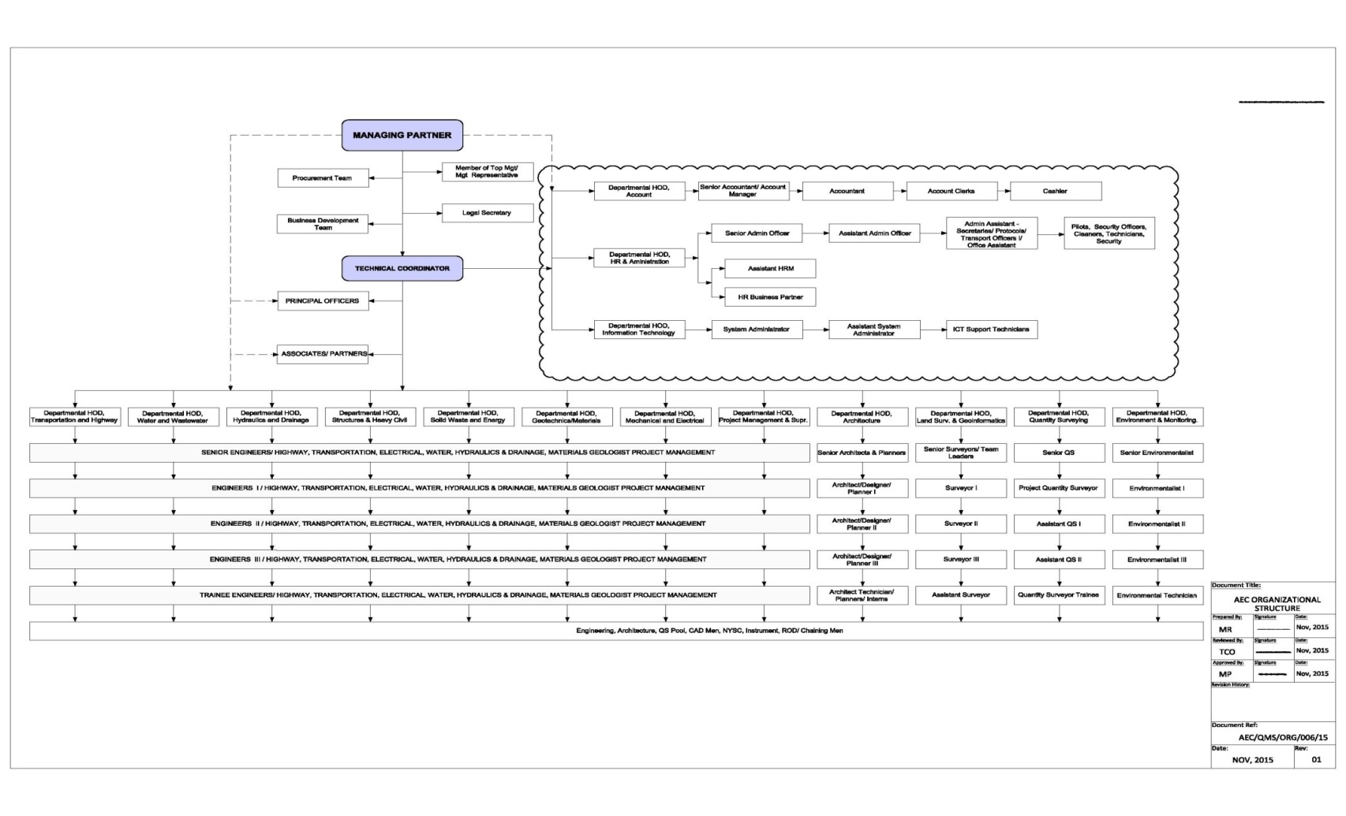

Figure 1.0: Organogram of Advanced Engineering Consultants

# CHAPTER 2

## 2.0 LITERATURE REVIEW

2.1 Building Structure

A Structure is an assembly of members each of which, under the influence of imposed loads is subjected to bending or direct force (either tensile or compressive) or to a combination of both (Reynolds, et al., 2008). The term structure can also be used to refer to any body of connected parts that is designed to bear loads. These said influences may be accompanied by shearing forces and sometimes by torsion. Some other factors that might be considered include effects due to changes in temperature to shrinkage and creep of the concrete. Possibility of damage resulting from overloading, local damage, abrasion, vibration, frost, chemical attack and in a variety of ways and depend, generally, upon the purpose for which the structure has been built. Building structures are in various shapes and sizes, dependent on the specified purpose it is to serve. Buildings range from small huts to gigantic high rise buildings.

Any structure whose intended use is for support, shelter or for continuous occupancy may be referred to as a building. Building are constructed, altered, upgraded, restored, demolished for different reasons, whether the aim is to provide more space or to make financial gain. From the speculative development, all building projects need to fulfill a function and meet a set of performance requirements, no matter how fundamental or sophisticated the client’s requirements might be.

The primary function of a building is to provide shelter, container for living, working and every other activity it is intended for. The principal functional requirements of a building may include the following:

• Shelter

• Security

• Safety and comfort

• Ease of use and operation

• Ease of maintenance, periodic repair and replacement

• Adaptability and durability

A structure must be capable of transmitting all loads carried by it to the ground. In doing so it must not collapse (Ultimate limit state) also must not deform excessively (serviceability limit state). A satisfactory structure is one which satisfies all these requirements as economically as possible. (T. Igba, 2017)

BASIC STRUCTURAL REQUIREMENTS ACCORDING TO INSTITUTE OF STRUCTURAL ENGINEERING.

Whatever the degree of safety of a given structure or the mode of its specification, some basic needs must, directly or indirectly be satisfied. The following requirements are put forward as expressing the fundamentals of safe construction, each of which, for a given structure, should be satisfied to a reasonable degree of probability:

a. That the structure shall retain, throughout its life, the characteristics essential for fulfilling adequately the purpose for which it was constructed, without abnormal maintenance cost.

b. That the structure shall retain throughout its life an appearance not disquieting to the user and general public, and shall neither have nor develop characteristics leading to concern as to structural safety.

c. That the structure shall be so designed that adequate warning of danger is given by visible signs; and that none of these signs shall be evident under design working loads.

It is generally not possible to ensure 100% that collapse will not occur or that excessive deformations will not occur. Structures are therefore designed so that the probability of it failing to satisfy these criteria is small enough to be acceptable. (Igba,2017)

## 2.1.1 Building components.

A building is broadly divided into two parts which are the substructure and the superstructure. The part of the building below the ground level is the substructure and the portion above it is called the superstructure. The Sub-structure or Foundation is the lower portion of the building, usually located below the ground level, which transmits the loads of the super-structure to the supporting soil. A foundation is therefore that part of the structure which is in direct contact with the ground to which the loads are transmitted.

Super-structure is that part of the structure which is above the ground level, and which serves the purpose of its intended use. A part of the super-structure, located between the ground level and the floor level is known as plinth. Plinth is therefore defined as the portion of the structure between the surface of the surrounding ground and surface of the floor, immediately above the ground.

Building components are all the members of a building that come together to make it serviceable and to meet its other requirements. The different components of a building are functions of one another. They can be said to be integrated to one another. It is impossible to consider a beam without putting into consideration the supporting columns or load bearing walls. The components of a building include;

* Foundation
* Floor
* Walls
* Roof
* Slab Panels
* Windows and doors
* Stairs and ramps.
* Columns and beams

## 2.1.2 FRAMED AND NON-FRAMED STRUCTURES.

A building structure can either be framed or unframed. A Framed structure is an assembly of slabs, beams, columns and foundation connected to one another so that they all act as one unit. Design of framed buildings enable the construction of tall buildings and building with stilts. Majority of modern structures and multistoried buildings are built as reinforced concrete framed structures. In a reinforced concrete framed structure, the load is transferred from slab to the beams then to the columns and further to lower columns and finally to the foundation which in turn spread the load to the soil. Thus, each element of the frame, that is, slab, beam, column and foundation must be designed to effectively handle its own dead load and the load being transmitted to it. The walls in such structures are constructed after the frame is ready and are not meant to carry any load, instead they are mostly used for partition purposes.

Unframed structures also known as load bearing structures, transfer loads through load bearing walls capable of transferring loads to the soil. A bungalow or two-storey building whose foundation is laid on a very good soil may be built without frames. The reinforced concrete slabs of the storey building may be supported by load bearing walls below it. Load bearing walls must be quality blocks that can safely carry the load imposed. Such blocks are mostly sandcrete blocks.

## 2.2 REINFORCED CONCRETE

Reinforced concrete is a combination of two different materials that compliment themselves, the materials are concrete and steel. Concrete has high compressive strength, durable and has good fire resistance but has a considerably little tensile strength. On the other hand, steel has good tensile properties but it behaves poorly under compression conditions and also has poor resistance to fire. Thus, a combination of these materials results in good tensile and compressive strength, increased durability and good resistance to fire and shear. The tensile strength of concrete is only about 10 percent of the compressive strength and on this basis, reinforced concrete structures are designed on the assumption that the concrete does not resist any tensile forces. Reinforcement provided cater for these tensile forces which are transferred by bond between the interface of the two materials. If this bond is not sufficient, the reinforcing bars will slip within the concrete and the reinforced concrete would lose its composite action properties. Therefore, during construction, concrete should be compacted well around the reinforcement. In the analysis and design of reinforced concrete section, there is said to be an almost perfect bond between concrete and steel reinforcement so that there is a compatibility of strains across the reinforced concrete cross section. The figure below shows the position of steel reinforcement to resist tensile forces, while the compression forces in the top of the beam are carried by the concrete.

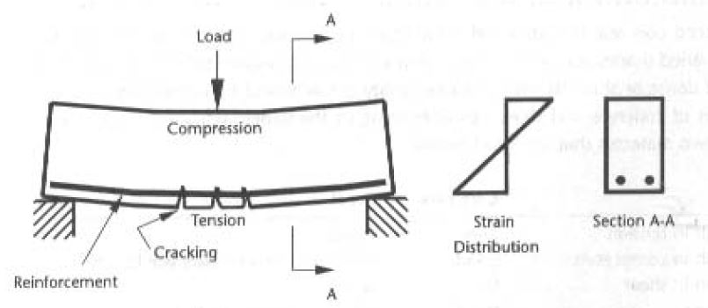

Fig 2.0: Action of Tensile and Compressive forces on a beam

Wherever tension occurs, it is likely that cracking of concrete will occur. The safety of the structure is not compromised due to this cracking, provided that the reinforcement bond with the concrete is good enough to ensure that the cracks are restrained from opening so that the embedded steel continues to be protected from corrosion. When the shearing force or compressive forces of the concrete exceeds its strength, steel reinforcement must again be provided to only supplement the load carrying capacity of the concrete.

Reinforced concrete, has occupied a special place in modern construction of different types of structures due to its several advantages. Italian architect Ponti once remarked that concrete liberated us from the rectangle. Due to its flexibility in form and superiority in performance, it has replaced, to a large extent, the earlier materials like stone, timber and steel. Further, the architect's scope and imaginations have widened to a great extent due to its mouldability and monolithicity. Thus, it has helped the architects and engineers to build several attractive shell forms and other curved structures. However, its role in several straight line structural forms like multi-storied frames, bridges, foundations etc. is enormous.

## 2.2.1 CONCRETE

Concrete is a composite material of a cement-based matrix, which is produced by mixing water, binder, and particles of aggregate. Binding material used can be cement or lime, while the aggregates are well graded fine and coarse. Concrete is a composite man-made material and it is the most widely used building material in the construction industry (Duggal, 2008). It is one of the oldest building materials known and has over the years it has become one of the most economic and durable materials used in the construction industry. A good quality concrete is essentially a homogeneous mixture of cement, coarse and fine aggregates and water which consolidates into a hard mass due to chemical action between the cement and water. The workability property of concrete allows it to be easily used to form many shapes ranging from bulky dam wall to very thin shell roof (Oyenuga, 2007). Concrete is considered one of the most important building materials, playing a part in all building structures, retaining structures and bridges. It can be molded to take up the shapes required for the various structural forms. It is also very durable and fire resistant when specification and construction procedures are correct.

In a mixture of concrete, cement and water form a paste which helps to fill the voids of the fine aggregate and also coats the surface of fine and coarse aggregates and binds them together. The paste is about 22-34% of the total volume. A freshly mixed concrete before setting occurs is known as a wet or green concrete whereas after setting and hardening it is known as set or hardened concrete. The molded concrete mix after curing becomes very hard like stone due to the chemical action that would have occurred between the water and cement. Most ancient structures and historical buildings had been constructed with lime concrete i.e. a concrete made using lime as the binding material. With the advent of cement, the use of lime concrete has decreased and it is only used to making bases for some concrete foundations and roof terracing. The major characteristics of concrete that has caused its wide usage are mouldability, early hardening, high early compressive strength, development of desired properties with admixtures to be used in adverse situations, pumpability and durability. The simple reason for its extensive use in the construction all civil engineering works is that the properties can be controlled within a wide range by using appropriate ingredients and by special mechanical, physical and chemical processing techniques. Buildings from single storey to multistory, bridges, piers, dams, weirs, retaining walls, liquid retaining structures, reservoirs chimneys, bins, silos, runways, pavements, shells, arches, railway sleepers and other civil engineering structures are applications where concrete is readily used.

Concrete can either be cast on site or in a factory. Most times Concrete is usually being cast on the construction site. Concrete which is cast in the factory or any other place from the construction site and later brought to site for use is called Pre Cast. Pre Cast Concrete is recommended where complex architectural finishes are required as it might be difficult to use concrete in situ in some situations. Examples include Construction of bridges and flyovers, piles.

Concrete is used for construction of bridges, buildings, roads, tunnels, dams, railway sleepers, oil rigs, water treatment plants amongst others. Concrete has been widely used because it is functional, strong, durable, fire resistant, Economical and versatile.

Concrete is generally strong in compression and weak in tension. If concrete is to be used for structural purposes, it is required to be added with other materials to cater for its deficiency. For example, steel is added to concrete to cater for its tensile deficiency as Steel is Strong in Tension.

There are different stages involved in the production of concrete which includes

• Batching – This is the proper and accurate measure of quantity of materials (i.e. cement, coarse aggregate, fine aggregate and water) required. Batching can be done by weight or volume depending on the size of the project. Factors which can affect the selection of batching method include; The size of the project, required production rate, and required standards of batching performance.

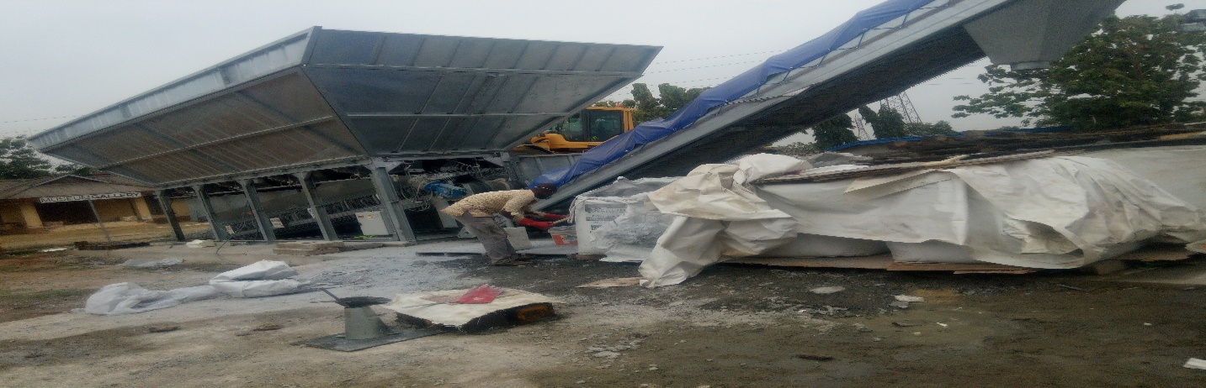

Plate 2.0: A Batching Plant

• Mixing – This is the process of making the concrete materials to make it a mass homogeneous substance and also makes it uniform in color and consistency. All the aggregate materials would have a coat of cement paste and all the ingredients of the concrete should blend into a uniform mass. The mixing is done either by hand or by a machine called the mixer.

• Transporting – This is the transfer of the mixed concrete to the place of deposition. This should be done as soon as mixing is done, to ensure that the mixed concrete does not lose its homogeneity obtained at the time of mixing. A maximum of 2 hours from the time of mixing is permitted if trucks with agitator and 1 hour if trucks without agitators are used for transporting concrete (Duggal, 2008). Segregation of the concrete materials should also be avoided during transport and placement of the concrete. The methods adopted for transporting concrete depend upon the size and importance of the job, the distance of the deposition place from the mixing place, and the nature of the terrain.

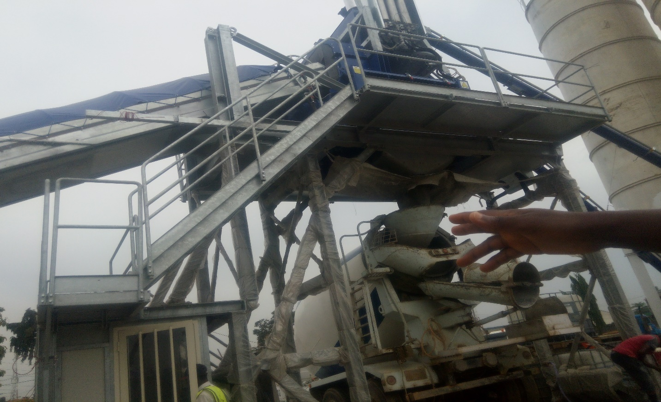

Plate 2.1: Picture Showing Mixed Concrete Ready for transport

• Placing – Concrete should be placed with utmost care to ensure its quality. This is done to secure the homogeneity which might have been achieved during mixing and to avoid segregation in transporting.

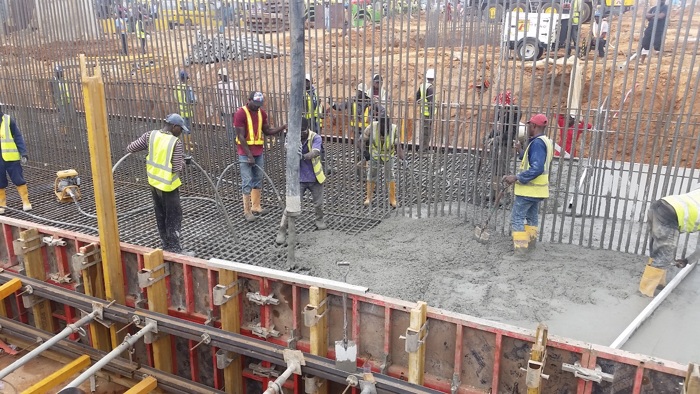

Plate 2.2: Placing of Concrete in progress

• Compaction – The compaction process helps to consolidate the freshly cast concrete within the formworks and around embedded parts and reinforcement steel. During production of concrete, some amount of air is entrapped in the concrete, and a possibility of partial segregation of the aggregates, both of which adversely affect the quality of the concrete. Compaction of concrete is the process of getting rid of entrapped air and voids in the concrete to eliminate the occurrence of segregation and to form the intended homogenous dense mass. According to Duggal (2008), 5 per cent voids in hardened concrete reduce the strength by over 30 per cent and 10 per cent voids reduce the strength by over 50 per cent. Therefore, the density and consequently the strength and durability of concrete greatly depends on the degree of compaction. For a concrete to achieve maximum strength, it must be compacted properly.

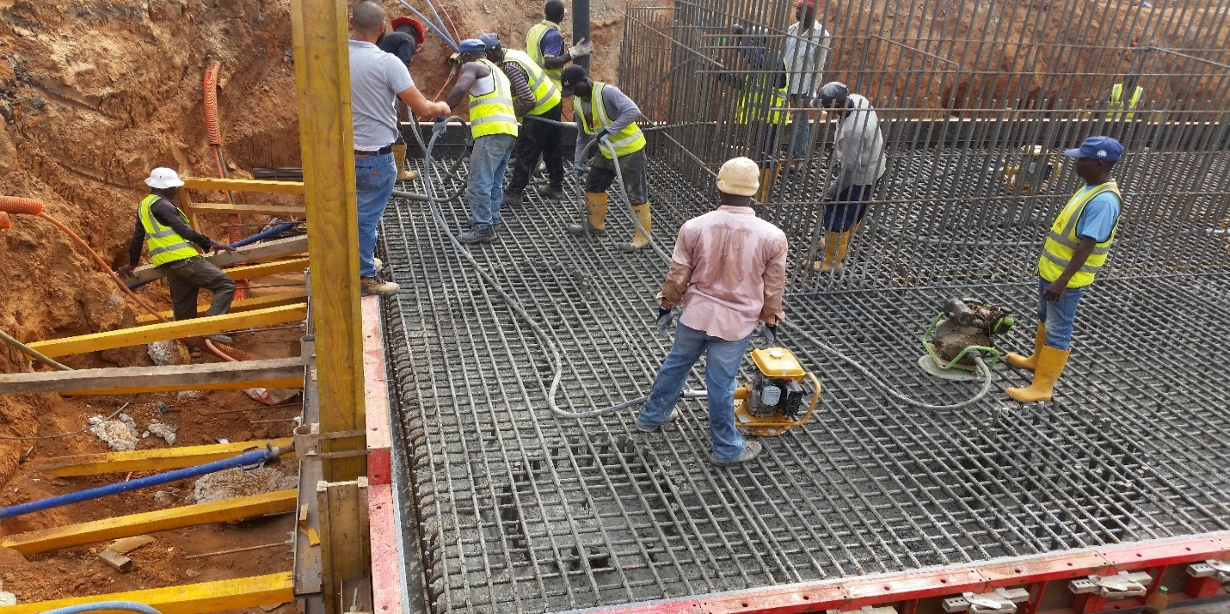

Plate 2.3: Compaction done using vibrators

• Curing – This is the process of keeping concrete damp and prevent the loss of moisture from concrete due to evaporation. The supply of additional moisture is needed to accelerate the gain of strength. Cement gains strength and hardness because of the chemical action between cement and water; this chemical reaction requires moisture, favorable temperature and time referred to as the curing period. Curing of freshly placed concrete is very important for optimum strength and durability and must be done for at least three weeks and in no case for less than ten days (Duggal, 2008). There are several methods of curing concrete which consists of either supplying additional moisture to concrete during early hardening period or by preventing loss of moisture from concrete by sealing its surface by membrane formed by curing compounds.

• Finishing – Concrete doesn’t have a very pleasant look after it is cast and sets. For this reason, it is very advisable to add finishing touches to the concrete to give it a more pleasant look when it sets. This process is called finishing. Finishing is the act of developing surface finishes to give a better appearance to concrete surfaces.

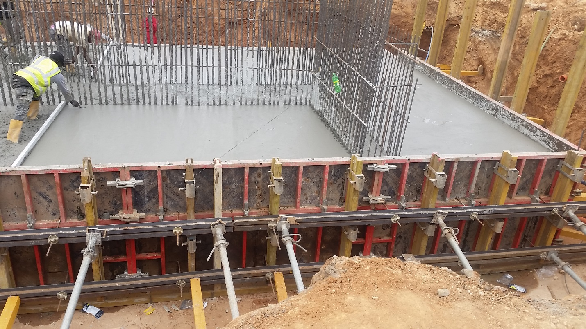

Plate 2.4: Finishing of already placed concrete

STRENGTH OF CONCRETE

Cement like water, aggregates and sometimes admixtures is one of the components that make up concrete. The mixing of these materials in specified proportions produces concrete. Accordingly cement alone is not a building material, concrete which is a composite of all the materials make up the building material. For a given cement and aggregates of choice, the strength that may be developed by a workable, properly placed mixture of cement, aggregates, and water (under same mixing, curing and testing conditions) is influenced by the:

a) Ratio of cement to mixing water.

b) Ratio of cement to aggregates, the strength of the mortar, the bond between the mortar and the coarse aggregate.

c) Grading, surface texture, shape, strength, and stiffness of aggregate particles.

d) Maximum size of aggregate.

Strength of concrete is directly related to the structure of the hydrated cement paste. Air in concrete produces voids. Excess of water in concrete also evaporates and leave voids in the concrete. Consequently, as the water-cement ratio increases, the porosity of the cement paste in the concrete also increases. As the porosity increases, the compressive strength of the concrete decreases.

**Compressive Strength**

The compressive strength of any material is defined as the resistance to failure under the action of compressive forces. For concrete, compressive strength is an important parameter to determine the performance of the concrete during service conditions. Concrete mix can be proportioned to obtain the required engineering and durability properties as required by the design engineer. Some of the other engineering properties of hardened concrete includes Elastic Modulus, Tensile Strength, Creep coefficients, density, coefficient of thermal expansion etc.

The Compressive strength of concrete is almost 10 times it’s tensile strength. In the design of reinforced concrete, the tensile strength of concrete is generally ignored. All tensile forces are being carried by the reinforcement. There is no direct relationship between the compressive strength and tensile strength, but factors which affect the compressive strength also affects the tensile strength.

Other important Properties of the concrete include deformation and durability.

The Compressive Strength of concrete is governed by;

➢ The bond between cement and aggregates.

➢ The Strength of the cement Paste matrix.

➢ The Strength of the aggregate.

The main parameters that influences the compressive strength of concrete are water content, air content and age. The compressive strength of concrete is determined in batching plant laboratories for every batch in order to maintain the desired quality of concrete during casting. The strength of concrete is required to calculate the strength of the members. Concrete specimens are cast and tested under the action of compressive loads to determine the strength of concrete.

In very simple words, compressive strength is calculated by dividing the failure load with the area of application of load, usually after 28 days of curing. The strength of concrete is controlled by the proportioning of cement, coarse and fine aggregates, water, and various admixtures. The ratio of the water to cement is the chief factor for determining concrete strength. The lower the water-cement ratio, the higher is the compressive strength.

|  |  |  |
| --- | --- | --- |
| CONCRETE GRADE | MIX RATIO | COMPRESSIVE STRENGTH AFTER 28 DAYS WITH CURING |
| M10 | 1:3:6 | 10N/MM2 |
| M15 | 1:2:4 | 15N/MM2 |
| M20 | 1:1.5:3 | 20N/MM2 |
| M25 | 1:1:2 | 25N/MM2 |
| M30 | 1:1:2 | 30N/MM2 |
|  |  |  |

Table 2.0: Table showing some concrete grades, mix ratios and compressive strength.

## 2.2.2 STEEL REINFORCEMENT

Concrete is a material which is strong in compression but weak in tension. If its tensile strength is exceeded, cracks will occur resulting in a weak and unsuitable building structure. One method of providing tensile resistance is to include in the concrete steel bars as a form of reinforcement to resist all the tensile forces induced. Steel is a material which is available and has tensile strength. Concrete reinforcing steel is available as standard reinforcing bars, spirals (for column reinforcing), and welded wire fabric (WWF). In planar element, reinforcement is used in form of a mat such as in the construction of the slab whereas in linear structural element, it is used in form of a cage such as in the construction of column. The standard length of reinforcement steel is 12m which is about 40ft. Steel reinforcement can be classified in different ways. The ways of classification are briefly summarized below;

• Classification based on size: Steel reinforcements come in different sizes based on their diameters. They are 8mm, 10mm, 12mm, 16mm, 20mm, 25mm, 32mm, 36mm etc.

• Classification based on strength: Classification of steel reinforcement in terms of strength are further subdivided into of two types:

* Mild steel: This type of steel has a smooth surface and it bonds with concrete by the principle of adhesion. They can be bent easily, therefore they are used more where bends of small radius are necessary. It is a ductile steel with a carbon content of about 0.15–0.25%. The characteristic strength of mild steel is 250N/𝑚𝑚2.
* High yield steel: This is a type of steel which is twisted or ribbed on the surface. They are the mostly used types of steel bars. It has a characteristic strength of 460N/𝑚𝑚2. High yield bars are used on site and the sizes used are 10mm, 12mm and 16mm. These reinforcement bars are used for lintels, beams, columns, column base and slab.

|  |  |  |
| --- | --- | --- |
|  | CONCRETRE | STEEL |
| Strength in tension | Poor | Good |
| Strength in compression | Good | good, but slender bars will buckle |
| Strength in shear | Fair | Good |
| Durability | Good | corrodes if left unprotected |
| Fire Resistance | Good | Poor |
|  |  |  |

Table 2.1: Comparison between properties of Concrete and Steel

## 2.3 DESIGN OF REINFORCED STRUCTURES

A reinforced concrete structure is a combination of beams, columns, slabs and walls, rigidly connected to form a monolithic frame (Mosley & Bungay, 1999). Each individual member must be capable of resisting the forces acting on it, so that the determination of these forces is an essential part of the design process. The forces in each member can then be determined by either applying moment & shear coefficients, manual calculations or through computer methods.

2.3.1 Design Objectives

The aim of structural design is the achievement of an acceptable probability that structures being designed will perform satisfactorily during their intended life (BS 8110 Part I, 1997). With an appropriate degree of safety, they should sustain all the loads and deformations of normal construction and use and have adequate durability and resistance to the effects of misuse and fire.

According to Oyenuga (2007), a good structural design must satisfy the following functional objectives:

• The structure must be safe under the worst combination of loading.

• The deformation of the structure must not impair the appearance, durability and/or performance of the structure under the working condition.

• The structure must be economical – the factor of safety should not be too large to the extent that the cost of the structure becomes prohibitive with no additional advantage(s).

Igba (2017) also stressed that the designed structures should also be durable on the long run. As materials of reinforced structures get affected by environmental conditions, structures having initial sufficient strength and permissible deformations may have their strengths reduced significantly and exhibit excessive deformations in the long run The designed structures should be durable. Therefore, structures must be thoroughly checked for durability to avoid problems of frequent repairing of the structure. Igba (2017) further added that the designed structures should adequately resist the effects of fire and misuse

Reynolds and Steedman (1999) also opined that an efficiently-designed structure is one in which the members are arranged in such a way that the weights, loads, and forces are transmitted to the foundation by the cheapest means consistent with the intended use of structure and the nature of the site.

2.3.2 Design Methods

To achieve the objectives of design, the following methods can be adopted:

(a) By dividing the ultimate strengths of materials with a certain factor (i.e. factor of safety) to provide design stress (strength). This method is called elastic method of design (or permissible stress method/modular-ratio method).

(b) By multiplying the load that the structure can withstand with a certain factor of safety to give the working load. This is called the load-factor method.

(c) Limit state method combines the advantages of the two methods above by applying factor of safety to both the materials and loads. This method also allows a varied factor of safety for various types of loading conditions (Mosley and Bungay, 1999).

The limit state design is based on the limit state approach which involves the achievement of acceptable probabilities that the structure being designed will not become unfit for its intended use. This means that all criteria relevant to both safety and serviceability are considered in the design process so as to make sure that the structure does not reach a limit state. An easy and usual approach is to design on the most critical limit state, and then to check that the remaining limit states will not be reached.

There are two types of limit state in structural design, namely:

(i) Ultimate limit state (ULS) – This limit state ensures that the structure is safe under the worst loading condition. This ensures resistance against collapse, buckling, stability or overturning, and other accidental/special hazards such as earthquake, explosion or fire.

(ii) Serviceability limit state (SLS) – the limit state that ensures that the structure is fit for normal use, i.e. serviceable. This is to ensure that the structure will not fail during service. It takes care of deflection, cracking, fatigue, vibration, durability, fire resistance and special circumstances such as earthquake resistance.

Except in water-retaining structures, the ULS is generally critical for reinforced concrete structures, while SLS conditions are checked. Conversely, in prestressed concrete design, serviceability conditions are the basis for designing with checks on the ULS conditions (BS 8110 Part I, 1997**). The code states that the values given for partial factors of safety γf ensure that serviceability requirements can generally be met by simple rules. The values of γf to give design loads and the load combinations for the ultimate limit state are given in BS8110: Part 1-1997,**

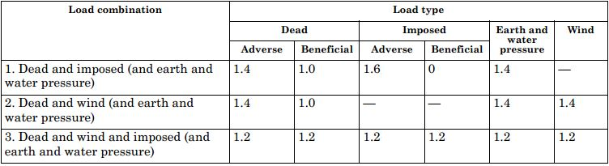

Table 2.2: Load Combination and values of **γf** for the ultimate limit state as represented in the BS 8110: Part 1-1997

Design Load = Characteristic Load × Partial Safety Factor for Loads = Fk x γf

Where fk is the characteristic load

The partial safety factor γf takes account of:

1. Possible increases in load

2. Inaccurate assessment of the effects of loads

3. Unforeseen stress distributions in members

4. Construction Inaccuracies

The characteristic strengths or grades of materials are as follows:

• Concrete, fcu is the 28 days’ cube strength in N/mm2

• Reinforcement, fy is the yield or proof stress of steel reinforcement in N/mm2

The specified characteristic strengths of reinforcement given in Table 3.1 of the BS 8110 Part1-1997 in the code are

• Hot rolled mild steel fy = 250 N/mm2

• High yield steel, hot rolled or cold worked fy = 460 N/mm2

Clause 3.1.7.4 of BS8110-Part 1: 1997 (Code of Practice for Design and Construction)

states that a lower value may be used to reduce deflection or control cracking.

The resistance of sections to applied stresses is based on the design strength which is defined as:

Characteristic Strength = fk

**Partial factor of Safety for Materials γm**

The factor γm takes account of:

1. Uncertainties in the strength of materials in the structure

2. Uncertainties in the accuracy of the method used to predict the behavior of members

3. Variations in member sizes and building dimensions.

Values of γm from can be found in Table 2.2 of the code of practice used for design for the ultimate limit state.

## 2.4 DESIGN PHILOSOPHY

The structural engineer is tasked to come up with a structural design that will meet the specification and satisfaction of the client. He must ensure that the structure is safe, economical in terms of construction, maintenance, and aesthetically pleasing.

Design has a wide range of definition, which is dependent on the perspective of different professionals. An architect may understand design as being the production of drawings and models to show what a new building will actually look like, that’s his professional perspective. Likewise, the Civil and Structural engineers have their own professional perspective of what design is. Design according to a civil or structural engineer can be said to be the planning of the entire process that might be involved in building a structure, bridge, tunnel, road, etc., from outline concepts and feasibility studies through mathematical calculations to working drawings which could show every detail of the project. Together with the drawings there will be bills of quantities, a specification and a contract, which will form the necessary legal and organizational framework within which a contractor, under the supervision of engineers and architects, can construct the scheme.

There are many inputs into the engineering design process, some of which include:

1. Client brief

2. Experience

3. Imagination

4. A site investigation

5. Model and laboratory tests

6. Economic factors

7. Environmental factors.

The first step for the design engineer is to have a conceptual brief from the client, who may be a private developer or the local, state or federal government. The conceptual brief may simply consist of some sketches prepared by the client or perhaps a detailed set of architect’s drawings. Experience is crucially important, and a client will always demand that the design engineer whose services he would be paying for has a standard experience from other related works he must have been part of. Most times it is wrongly assumed that imagination should be strictly the architect’s job, this is not so. Engineers and technicians must also have an outstanding imagination of how elements of a structure interrelate in three dimensions, which gives an appreciation of the loadings to which structures might be subject in certain circumstances. In addition, imaginative solutions to engineering problems are often required to save money, time, or to improve safety or quality.

Site investigation is essential to determine the strength and other characteristics of the soil on which the structure will be founded. If the structure is unusual in any way, or subject to abnormal loadings, model or laboratory tests may also be used to help determine how the structure will behave.

The structural designer must be economically conscious and constantly aware of the cost implications of his design. Design should aim to achieve that the materials used in the structure are economical. In addition, the actual cost of the designer’s time should not be excessive, or this will undermine the employer’s competitiveness. The idea is to produce a workable design achieving reasonable economy of materials, while keeping manufacturing and construction costs down, and avoiding unnecessary design and research expenditure. Attention to detailing and buildability of structures cannot be overemphasized in design. Most failures are as a result of poor detailing rather than incorrect analysis. Designers must also understand how the structure will fit into the environment for which it is designed. Today many proposals for engineering structures stand or fall on this basis, so it is part of the designer’s job to try to anticipate and reconcile the environmental priorities of the public and government. The engineering design process can often be divided into two stages:

(1) A feasibility study involving a comparison of the alternative forms of structure and selection of the most suitable type and

(2) A detailed design of the chosen structure. The success of stage 1, the conceptual design, relies to a large extent on engineering judgment and instinct, both of which are the outcome of many years’ experience of designing structures. Stage 2, the detailed design, also requires these attributes but is usually more dependent upon a thorough understanding of the codes of practice for structural design, e.g. BS 8110 and BS 5950. These documents are based on the amassed experience of many generations of engineers, and the results of research. They help to ensure safety and economy of construction, and that mistakes are not repeated

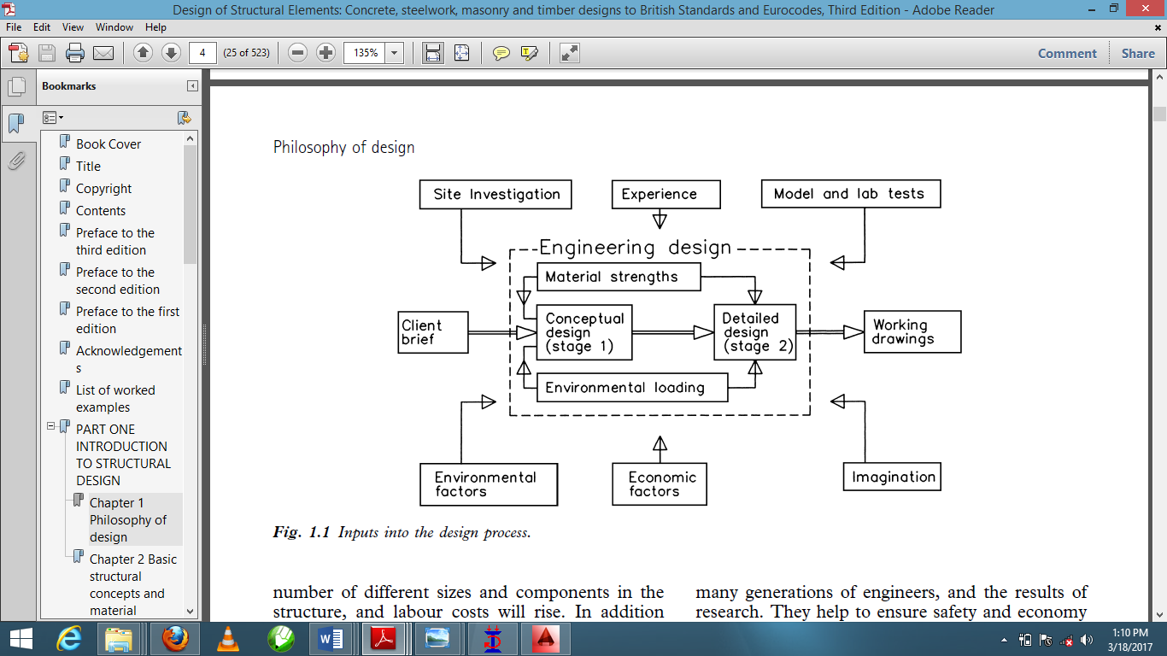

Fig. 2.1: Inputs into the design process

## 2.5 THE DESIGN PROCESS

In design, appropriate attention must be paid to the overall economy, the safety, serviceability and aesthetics of the structure. Design processes in most cases entails finding the cheapest solution capable of satisfying the safety, serviceability and aesthetics consideration (Allen,1998). Structural design is an art and science of understanding the behavior of structural members subjected to loads and designing them with economy and elegance to provide a safe, serviceable and durable structure. The process of design in a chronological order is given below:

1. Structural planning

2. Action of forces and computation of loads

3. Structural analysis

4. Structural design

5. Detailing of Structural members

6. Preparation of Bar bending schedules

2.5.1 Structural Planning

After obtaining the architectural plan of a building, the structural planning is the next process in line. For a proper structural planning, an accurate general arrangement must be put in place. The general arrangement is derived from the architectural drawing. The general arrangement clearly specifies the disposition of the structural elements such as the columns, beams, and the paneling of the floor slabs. This involves the determination of the following;

• Position and orientation of columns: Columns should preferably be located at (or) near the corners of a building, and at the intersection of beams/walls. The selection of the preferable position of columns helps in reducing bending moments in beams, avoid larger span beams, avoid large center-to-center distance between columns.

• Positioning of beams: Beams are normally provided under walls or below a heavy concentrated load to avoid these loads directly coming on slabs. Larger spans of beams are usually avoided due to deflection and cracking also to avoid uneconomical use of steel reinforcement in a single member.

• Spanning of Slabs: This is determined by support arrangements. When supports are only on opposite edges or only in one direction, then the slab acts as a one way supported slab. When the rectangular slab is supported along its four edges, it acts as a two-way slab. Also, when the ratio of the longer span and the shorter span is less than two, the slab is identified as two-way slab and designed as such (Ly/Lx < 2). But when the ratio of the longer span and the shorter span is greater than two, the slab is identified as one-way slab and designed as such (Ly/Lx ≥ 2). While the steel reinforcement along the long span just acts as the distribution steel and is not designed for transferring the load but to distribute the load and resist shrinkage and temperature stresses. The provision of more steel in one direction of a one-way slab, increases the stiffness of the slab in that direction. Cracking at the edges of one way slabs can be avoided by providing minimum steel reinforcement at the top corners of the slab.

• Type of footing/foundation: Foundation/Footing carries the load imposed by the entire structure. The type of footing used in a structure essentially depends upon the load carried by the column and the bearing capacity of the supporting soil. The soil under the foundation is susceptible to large variations. The nature and properties of soil may change with climatic conditions, like swelling of the soil during rainy season. It is necessary to conduct the soil investigation in neighboring areas around where the proposed site is situated to ascertain soil properties. For framed structures, isolated column footings (pad bases) are normally preferred except in cases where there are needs for extreme depths, pile foundations can be an appropriate choice. If columns are very closely spaced and bearing capacity of the soil is low, raft foundation can be an alternative solution.

2.5.2 Action of Forces and Computation of Loads

After the proper structural planning of the project at hand, the next process is the computation of loads due to action of forces. In this process, forces and loads that would act on each structural member is calculated. These said forces include; Shear Force, Torsion, Column Load, Wall Loads, Cantilever reactions etc. Loads are forces that act directly on a structure. Loads can be permanent loads which include Self weight of structural members, fittings, finishes and fixed equipment. These loads can also be referred to as the dead loads. Loads acting on the structure can also be imposed loads, wind loads and snow loads. Another type of loads that can be considered is the accidental load which might be caused by explosions or impact from vehicles. Loads are specified by their characteristic values which can be obtained from various loading codes such as;

BS 648: 1964 Schedule of weights of building materials

BS 6399: Loadings for buildings

BS 6399: Part 1: 1984 Code of practice for dead and imposed loads

BS 6399: Part 2: 1997 Code of practice for wind loads

BS 6399: Part 3: 1988 Code of practice for imposed roof loads

Design loads are usually obtained by multiplying the characteristic loads by suitable partial safety factors, γf.

In a more explanatory way, the loads on a structure are divided into two types:

• Dead Loads: Dead loads are those which are normally permanent during the structure’s life. Dead loads include the self-weight of the structure and all architectural components such as exterior cladding, partitions and ceilings, floors, finishes weight of walls and others. Fixed equipment and static machinery are also often considered as part of dead load. For most reinforced concretes, a typical value for the self-weight γcu is 24kN/m3, but a higher density should be taken for heavily reinforced or dense concretes. In the case of a building, the weights of any partitions should be calculated from the architects’ drawings. A minimum partition imposed loading of 1.0kN/m2 is usually specified, but this is only adequate for light-weight partitions (Mosley & Bungay, 1999). The characteristic dead load is denoted by Gk and load per unit area is denoted by gk .

• Live/Imposed Loads: Live/Imposed/Characteristic variable loads on the other hand, varies in magnitude, as for example those due to wind, snow, furniture or human occupants. These loads are more difficult to determine accurately. For many of them, it is only possible to make conservative estimate based on standard codes of practice or experience. Although the wind load is an imposed load, it is kept in a separate category when its partial factors of safety are specified, and when the load combinations on the structure are being considered. Imposed loads are loads assumed to be produced by the intended occupancy or use, including the weight of movable partitions, distributed, concentrated, impact and inertia, loads, but excluding wind loads. They are loads that change in magnitude with respect to time. The characteristic Imposed load is denoted by Qk and load per unit area by qk. Various combinations of the characteristic values of dead load Gk, imposed load Qk, wind load Wk and partial factor of safety must be considered for the loading of the structure. These partial factors of safety are specified by the British Standard code BS 81102.

2 Part 1: Code of Practice for design and construction (1997)

For ultimate limit state, the loading combinations are as follows:

1. Dead and imposed load

1.4Gk + 1.6Qk

2. Dead and wind load

1.0Gk + 1.4Wk

3. Dead, imposed and wind load

1.2Gk + 1.2Qk + 1.2Wk (Mosley & Bungey, 1999)

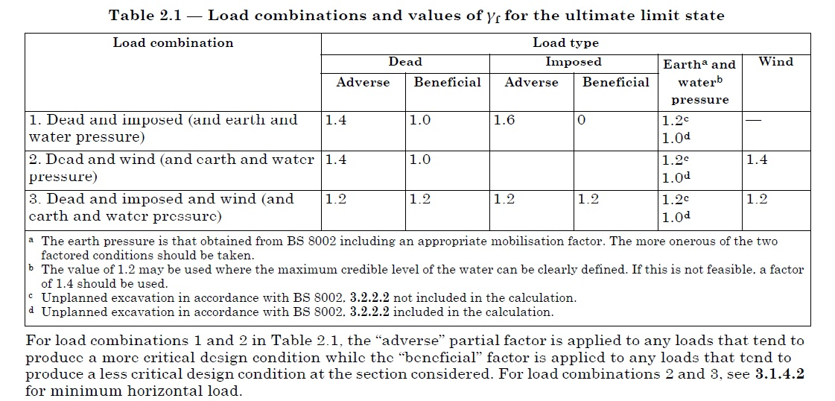

Fig 2.2: Figure showing the load combinations and values of γf for ULS (BS8110 clause 2.4.3)

The design value of a load Fd can be expressed in general terms as Fd = γf Fk .

Where Fk is the characteristic value of the load, and γf is a partial safety factor appropriate to that load. Specific examples for loads are;

Design Dead load = γf Gk

Design Imposed load = γf Qk

Design Wind load = γf Wk

In the design of a structure at Ultimate limit state, the design load combination used according to BS 8110 -1-1997 Clause 2.4.3.1.1 is

Fd = 1.4 Gk + 1.6 Qk

Where 1.4 and 1.6 are partial factors of safety for dead loads and live loads respectively.

## 2.5.3 Structural Analysis

Structural Analysis is the prediction of the performance of a structure under prescribed loads and other external effects, such as support movements and temperature changes through calculations. The performance characteristics include: stresses, axial forces, shear forces, bending moments, deflections and support reactions. These loads could be in the form of dead loads (element self-weight, finishes, partitions), imposed loads (people, furniture), wind loads, earth pressures etc.

The primary objective of structural analysis is, for each loading combination, to obtain a set of internal forces and moments throughout the structure that are in equilibrium with the design loads for the required loading combination. Structural analysis is usually carried out for horizontal structural members (such as beams, slabs and footings), and seldom for vertical structural members (such as columns and walls).

A structure can either be statically determinate (the equations of static equilibrium are sufficient to analyze the structure, i.e. ΣFx=0, ΣFy=0, ΣM=0) or statically indeterminate (the equations of static equilibrium are not sufficient to analyze the structure).

Basically, the static determinacy of a structure is determined by the following equation: n = r – e

where n = number of redundant forces

r = number of reactions

e = number of equations of static equilibrium (e = 3)

Hence, if a section of the structure is found to be statically determinate (such as in the case of beams, lintels, etc.), the internal forces and moments are obtained from basic equations of static equilibrium. However, if the section(s) is (are) found to be statically indeterminate, the internal forces and moments are obtained from appropriate method(s) of analysis of indeterminate structures.

Analysis must begin with an evaluation of all the loads carried by the structure, including its own weight. The loads are variable in magnitude and position, and all critical arrangements of loads must be considered. The structure itself is broken into simple sub-structures that represents the load carrying action. The Force in each member can then be determined by either of the following methods:

1. Applying moment and shear coefficients
2. Manual calculations
3. Computer Programs.

Moments and Shear coefficients can be used when dealing with a simple, regular structure like equal-span continuous beams carrying uniform loads. Manual calculations are used for vast majority of structures, but may be very tedious for complicated ones. Computer programs have been of great help in analysis of structures as they’ve made analysis of structure easier and they also provide designers with the opportunity of analyzing more complicated structures accurately.

Structures such as; slabs (one-way spanning slabs, two-way spanning slabs, and cantilever slabs), simple staircases, slab strips, single span beams, continuous beams with equal and unequal spans, can be analyzed manually.

This is carried out by the design engineer by making appropriate use of the basic formulas and methods such as;

* For Simply supported members the following formulas apply;

*wl2*/8 & wl/2 is used to determine maximum bending moments and shear force respectively in **simply supported elements under uniformly distributed loads**

*pl*/4 & p/2 is used to determine maximum bending moments and shear force respectively in **simply supported elements under point loads**

*wl2*/2 & wl/2 is used to determine maximum bending moments and shear force respectively in **cantilever elements under uniformly distributed loads**

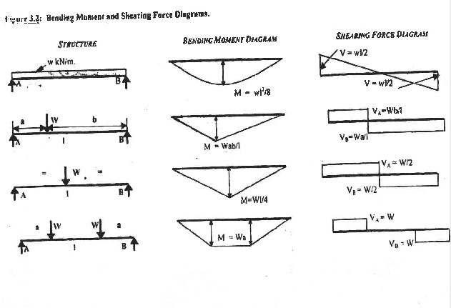

*Fig 2.3 Showing Maximum bending moments and shear force diagrams for simply supported members*

* For Continuous members such as Beams and slabs, the following methods can be used for analysis.

*Methods: 1. Hardy cross Moment Distribution Method*

*2. Claperyon’s Three moment equation*

*3. Coefficient method for nearly equal spans according to BS8110 code of practice*

1. Hardy Cross Moment distribution method

This is a method of analyzing frames by distributing the fixed end moments of members according to their relative stiffness’s. It is used mainly for analyzing sub frames, where a simplified analysis is sufficient.

The stages of moment distribution are as follows: -

* Calculate member stiffnesses
* Calculate distribution factors
* Calculate fixed end moments
* Distribute moments according to stiffness by an iterative process until a balance is reached

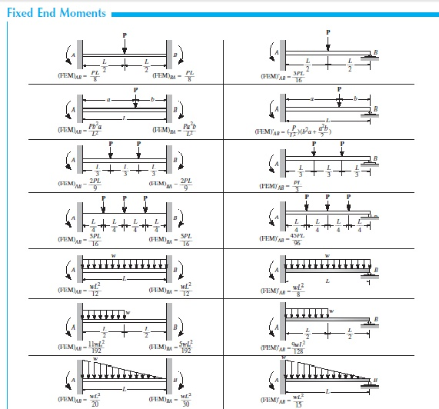

*Fig 2.4 Showing fixed end moments for various loading conditions*

2. Claperyon’s three moment equation

The three moments equation expresses the relation between the bending moments at three successive supports of a continous beam subjected to loading on the various spans with or without settlement of the supports. The moments at the supports are taken to be unknowns.



Fig 2.5: A loaded continuous member

3. Coefficient method for nearly equal spans (BS8110 clause 3.4.3)

The figure below may be used to calculate the design ultimate bending moments and shear forces, subject to the

following provisions:

a) characteristic imposed load *Q*k may not exceed characteristic dead load *G*k;

b) loads should be substantially uniformly distributed over three or more spans;

c) variations in span length should not exceed 15 % of longest.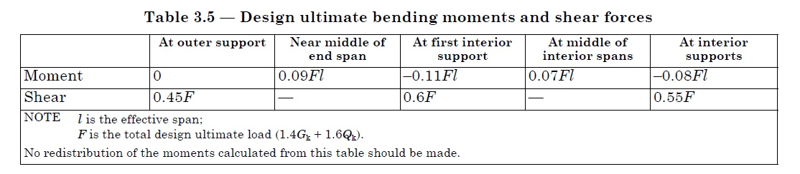 *Fig 2.6 moments and shear force coefficients for continuous span elements Table3.5 of the Bs 8110 1-1997 code*

Structural Analysis/Modelling using computer programs

Structural analysis and design can also be done using computer programs also. They can also help in modelling the intended structure. This programs make the work of the design engineers less tedious and time saving. These programs give the engineer an option to input values which will be processed by the program, and produce desired results. These results can come in form of Numerical Values and can also be displayed graphically. CSC products which include **ORION** and **TEDDS** were used during my training. This software gives the engineer full control of his/her analysis as well as the ability to probe easily as the software uses the coordinate system of modeling.

## 2.5.4 Structural Design

Design procedures assume the use of normal-weight aggregate and are extracts of the provisions in BS 8110 1997: Part 1. However, in certain cases, the recommendations of the appropriate clauses of the code may be inappropriate, it is thus imperative for the engineer to adopt a more suitable method having regard to the nature of the member in question.

Reynolds and Steedman (1999) explains that, when designing in accordance with limit-state principles as embodied in BS 8110, each reinforced concrete section is first designed to meet the most critical limit state and then checked to ensure that the remaining limit states are not reached. For the majority of sections, the critical condition considered is the ultimate limit state – at which the strength of each section is assessed on the basis of conditions at failure. When the member has been designed to meet this limit-state, it should be checked to ensure compliance with the requirements of the various serviceability limit state such as deflection and cracking.

Durability of concrete is another thing to consider in the design process. A durable concrete element is one that is designed and constructed to protect the embedded metal from corrosion and to perform satisfactorily in the working environment for the lifetime of the structure. This is achieved through careful consideration of the following factors which influence the durability of concrete:

• Design and detailing of the structure (clause 3.1.5.2.1)

• The cover to the embedded steel (clauses 3.3)

• Exposure conditions (clause 3.3.4)

## 2.5.5 Detailing of Structural Members

Detailing is the presentation of the design in a diagrammatic form for the purposes of execution of the project. The detailed drawings are what the contractor or builder use on site and, hence, should be a complete and true reflection of the design as carried out by the engineer. A very good design but badly detailed can be catastrophic and the engineer should check very well the detailed drawings after the draughtsman must have finished working on them (Oyenuga, 2007). This involves the provision of reinforcement bars and appropriate details to ensure satisfactory behavior, to satisfy the design areas of reinforcement, ensure buildability and ease of construction on site.

The detail structural drawing gives the following information:

• Size and positioning of reinforcement

• Depth of cover, concrete strength, etc.

• Dimensions and outlines of the structural units

A detail drawing is the only positive link between the design engineer and the contractor and hence should be easy to read and understand because it is of little use to produce a drawing that looks impressive to an engineer but cannot be fully understood by the man placing and fixing the reinforcement (Boughton, 1971). Below is a list of vital points that must be indicated on good, clear detail drawings:

• A reasonable scale should be adopted for each unit.

• Grid lines, where used, should run in sequence on plans, numbers, e.t.c. (from top to bottom) and letters A, B, C, etc. (from left to right) so that beams and columns can be easily referenced when shown in isolation on detail drawings, or called up on schedule sheets.

• Plans, elevations and sections should be clearly defined.

• Sections through plans should always, also, be taken in a uniform direction, usually left downward.

• Dimension lines of structural units, where no general layout drawing is provided, should always be taken outside the member to avoid confusion; however, a general layout drawing is preferable in which case the reinforcement drawing will not show unit dimensions.

• For clarity sake, section’s outline should be in thicker line form other than those of the plans and elevations.

• Reinforcement should be in heavy line since it is the most important item on the drawing.

• An indication of the reinforcement with one (or two, if alternate) typical bar only in full should be shown on plans and elevations. The bar should also be fully located on either plan or section.

• Bars should be called up separately for each unit, and not repeated where a similar bar is used in another unit on the same drawing.

• Bars should be referenced in their likely order of placing to make the steel reinforcement fixers’ job more straightforward.

• Each drawing should start from bar mark 1.

• Cover should be shown on the section where it varies from one unit to another on a drawing. Where it is constant, it can be called up in the notes.

• Where only one type of reinforcement is used throughout a drawing, it is unnecessary to indicate its type on every set of bars since it can be called up in the notes’ column.

• Certain standard abbreviations can be used in calling up reinforcement, e.g.

For type of reinforcement:

(i) Mild Steel bars ----------- R

(ii) High Tension bars ------- Y

For placement of reinforcement:

(i) Bottom face --------------- B

(ii) Top face ------------------- T

(iii) Near face ----- N. F.

(iv) Far face ------- F. F.

(v) Each face ----- E. F.

(vi) Both ways ---- B. W.

For arrangement of reinforcement:

(i) c/c --------------------------- Centre to Centre

(ii) thro’out --------------------- Throughout

• The bar mark and size should be grouped in a single numeral where the diameter precedes the bar mark.

• Spacing of reinforcement should be in 25mm increments from 50mm above.

• Normal bar diameters used should be of the order: 6, 8, 10, 12, 16, 20, 25, 32 and 40mm.

• Bars should be called up in the following manner: No. required/ Type of steel/ Diameter or size/ Bar mark/ spacing (if required)/ location/ any special consideration, e.g. 20 – R1205 – 150 c/c T means 20 no. of mild steel bars of 12mm diameter, bar mark 5, are required at 150mm Centre to Centre at the top of the slab.

## 2.5.6 Preparation of Bar Bending Schedule

Detail structural drawings should generally be accompanied with bar bending schedule. Bar bending schedule is a detailed tabulated worksheet showing the particulars of reinforcing bars as needed in reinforcement drawings of a structure. Bar bending schedule gives dimensions and markings of steel reinforcement so that information on quantity, shape and size can be provided for supply. The word “Bar Bending” is used because at the steel yard where different types of reinforcement are cut and bent this table is used as a reference to bend the reinforcement bars in desired and required shape and sizes. Reinforcement schedules must conform to BS 8666: 20003. BS 8666: 2000 – Specification for Scheduling, Dimensioning, Bending and Cutting of Steel Reinforcement for Concrete.

A bar bending schedule sheet should contain the following information:

• Member – the location in which the bar is used.

• Bar mark – the number of the bar in its sequence on the detail drawing.

• Type and size – the type of steel used and its diameter.

• Number of members – the number of identical units, which can occur in each member.

• Total number – the number of members × the number of bars in each member.

• Length of each bar – the overall length in meters and millimeters allowing for bending tolerances etc. This should always be rounded off to the nearest 5mm.

• Shape -- this shows the bending of the bar with critical dimensions indicated.

• Weight of each bar per meter length

It must be noted that the preparation of bar bending schedule, as part of the detail drawings, is the responsibility of the engineer (Boughton, 1971). Schedule sheets are used, not only by the steel supplier and steel fixers; but, also, by the quantity surveyor to prepare the bill of quantities.

In recent times, bar bending schedules are often generated with Computer Aided Design (CAD) software with the popular one being AutoCAD.

The Importance of the bar bending schedule is listed below;

* On the availability of the bar bending schedule, cutting and bending of reinforcement can be done at the steel factory and transported to site. This makes work faster on the construction site and also reduce construction time and cost.
* It helps to improve quality control on site as reinforcement is provided as per bar bending schedule which is prepared using the provisions of respective detailing standard codes.
* It provides a better estimation of reinforcement steel requirement for every structural member which can be used to compute overall reinforcements requirement for the entire project.
* Bar bending schedule can be used for reinforcement cutting, bending and making skeleton of structural members before it can be placed in the required position.
* Bar bending schedule provides a better stock management for reinforcement. Steel requirement for next phase of construction can be estimated with accuracy and procurement can be done. This helps to prevent stocking of extra steel reinforcement at site for a long time and also prevents corrosion of reinforcement on site when they’re not used over a long time especially in areas susceptible to water.

For all concrete structures, Ultimate limit states are more critical than serviceability limit states, so structures are designed for Ultimate loadings using appropriate factors. Serviceability requirements to control deflections and crack widths are satisfied within the ultimate limit state by

* Checking the span to effective depth ratio;
* Providing not less than the minimum permitted percentage of reinforcement
* Limiting the space for tension reinforcement

## 2.6 ROAD DESIGN

Road selection and design largely depends on the nature of the subgrade; the traffic and drainage conditions; the construction time available; the supply of local and imported materials; and the equipment, available personnel and expertise available. The completed design must then meet the requirements for the given load class and allow safe and efficient traffic movement.

The Federal Republic of Nigeria’s Highway manual part 1: Design, volume I: Geometric Design states that the overall philosophy of road design is based on the assumption that any design that complies with the established geometric design guidelines is safe and that those that do not are unsafe. This philosophy emphasizes that safety should be of utmost consideration. Sacrificing safety in the interest of efficiency is not acceptable practice. A comprehensive approach should be founded on the concept of reducing the probability of failure to the lowest possible level and to minimize the consequences of failures that could occur. To achieve this, a design must start with a clear understanding of purpose and functionality. From this basis, design elements should be selected to integrate into the landform and current and future use.

The load-carrying capacity of a road surface depends on continuous, stable support furnished by the subgrade. Subgrade stability requires adequate drainage and proper load distribution by the surface and base courses. Surface and base courses of sufficient thickness and quality to spread the wheel loads over the subgrade are necessary so that the applied stress is less than the unit load capacity of the subgrade. In areas where seasonal freezing and thawing occur, the load-carrying capacity of inadequately designed or improperly constructed roads can be dramatically decreased to the extent that failure may occur.

For safe and speedy traffic movement, the geometric design requirement for given road classes must be met. An improved network of well-surfaced, high-quality roads may be required in rear areas and near major airfields, ports, and supply installations. Road design uses stage construction for the progressive improvement of the road to meet increased traffic demands. Road design also uses many technical terms.

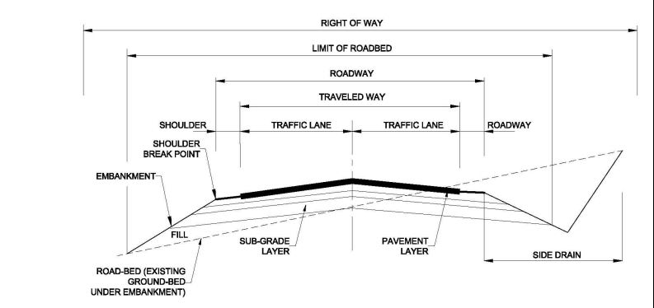

Fig 2.7: Road Cross Section Elements

## 2.6.1 Geometric Design of a road

Geometric design principles are used to establish the horizontal and vertical alignment, including consideration of the driver, the vehicle, and roadway characteristics. The proper geometric design of a highway ensures that drivers use the facility with safety and comfort. The process achieves this by selecting appropriate vertical and horizontal curvature along with physical features of the road such as sight distances and super elevation. The ultimate aim of the procedure is a highway that is both justifiable in economic terms and appropriate to the local environment.

## 2.6.2 SIGHT DISTANCE

The ability to see ahead on a road is very important in the safe and efficient movement of vehicles on that road. That is why it is necessary to provide sufficient lengths for sight distances so that drivers can efficiently control the movement of their vehicles to avoid hitting an unexpected object on the way. The three sight distances that are usually considered in the design of a road are:

1. Stopping sight distance
2. Passing sight distance
3. Decision sight distance.

According to the Nigerian highway manual, the stopping sight distance is used when designing for multilane and two lane roads, including private road connections, while passing sight distance should be provided on 2-lane highways at frequent intervals and over a substantial portion of their length. The decision sight distance is taken into account when designing for freeway and interchange.

* STOPPING SIGHT DISTANCE: Stopping sight distance is the least sight distance required on a road to enable a vehicle travelling at its design speed on a road pavement to stop before reaching an object on its path. Stopping sight distance is usually taken as the sum of the brake reaction distance and stopping distance respectively. The brake reaction distance is the distance covered by the vehicle from the moment the driver sees an obstructing object necessitating it to stop to the instant the brakes are applied. The stopping distance is the distance that is required to stop the vehicle from the instant that the brakes are applied. The Nigerian highway manual states that the Stopping sight distance is measured from the driver’s eye level which is assumed to be 1.05 meters above the pavement level to all objects 600mm high on the road.
* PASSING SIGHT DISTANCE: This is the minimum sight distance that must be available to enable the driver of one vehicle to overtake another vehicle safely and comfortably without interfering with the speed of an oncoming vehicle, should the oncoming vehicle come into view after the overtaking maneuver is started. The Nigeria highway manual states that the sight distance available for passing at any place is the longest distance at which a driver whose eyes are 1.05 meters above the pavement surface can see the top of an object 1.30 meters high on the road. This height will allow a driver see the roof of an upcoming car. Passing sight distance is only considered on two lane roads. The passing sight distance criteria does not apply for multilane divided roads where opposing traffic streams are segregated. Passing sight distance is made up of three distance components; d1, d2, d3.

D1= Distance travelled by the vehicle in question while driver in the overtaking vehicle completes the passing time.

D2= Distance between the overtaking and opposing vehicles at the point in time at which the overtaking vehicle returns to its designated lane.

D3= Distance travelled by the opposing vehicle within the perception reaction time and overtaking time.

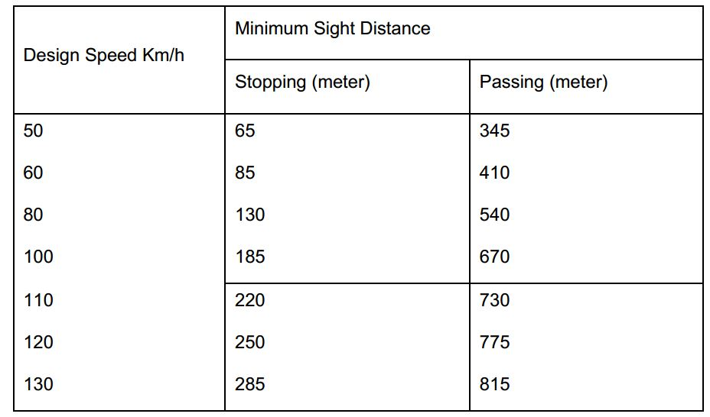

Table .2.3: Sight Distance Standard as represented in the Nigeria highway manual.

* DECISION SIGHT DISTANCE: Decision sight distance also referred to as anticipatory sight distance is the distance required for a driver to detect an unexpected or difficult to perceive information source or hazard in a road that might be visually cluttered, recognize the hazard or its potential threat, select an appropriate speed and path and initiate and complete the required safety manoeuver safely and efficiently. (Nigeria Highway Manual). Critical points on the road where it is advisable to provide decision sight distance are, approaches to interchanges and intersections, changes in cross sections, when there is a design speed reduction and areas where there is a concentrated amount of visual noise. Visual noise can include sources of information on the road such as roadway elements, traffic control devices, advertising signs and construction zones compete for attention.

## 2.6.3 HORIZONTAL ALIGNMENT

Horizontal alignment deals with the design of the directional transition of the highway in a horizontal plane. A horizontal alignment basically consists of a horizontal arc and two transition curves forming a curve which joins two tangents. In certain situations, the transition curve may have zero length. The design procedure itself must commence with fixing the position of the two straight lines which the curve will join together. The basic parameter relating these two lines is the intersection angle. Figure 6.10 indicates a typical horizontal alignment.

In setting out the horizontal alignment, the following major factors are considered;

* Safety
* Grade Profile
* Type of Highway
* Design Speed
* Topography
* Cost (Construction, maintenance, operation)

From the Nigeria highway manual, of all these considerations, safety shall be considered to be of paramount importance. The horizontal alignment provided shall ensure that the stopping distance for the design speed shall be adequate at all points on the highway. In hilling terrain, the alignment and grade profile may constitute a major control when designing a two lane highway. Topography controls both curve radius and design speed to a large extent. The design speed in turn controls sight distance. The cost of construction, maintenance and operation must be balanced carefully against the other factors in order to produce the safest alignment consistent with the design classification of the road.

HORIZONTAL CURVES

When a highway changes horizontal direction, making the point where it changes direction a point of intersection between two straight lines is not feasible. The change in

direction would be too abrupt for the safety of high-speed vehicles. Therefore, it is necessary to interpose a curve between the straight lines. The straight lines of a road are called tangents because the lines are tangent to the curves used to change direction. On practically all modern highways, the curves are circular curves, or curves that form circular arcs. The smaller the radius of a circular curve, the sharper the curve. For modern high-speed highways, the curves must be flat, rather than sharp. That means they must be large-radius curves.

The principal consideration in the design of a curve is the selection of the length of the radius or the degree of curvature. This selection is based on such considerations as the design speed of the highway and the sight distance as limited by headlights or obstructions.

TYPES OF HORIZONTAL CURVES

Horizontal curves are of four types. They are described as follows;

1. Simple Curves: A simple curve is an arc of a circle. The radius of the circle determines the sharpness or flatness of the curve. A typical simple curve is shown in the figure below.

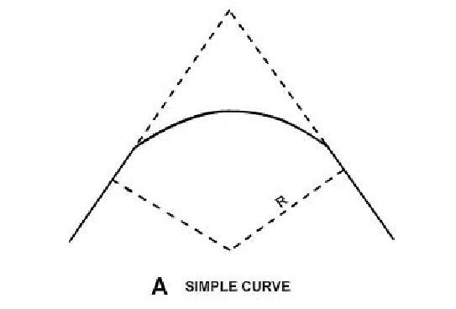

Fig 2.8: A simple curve.

1. Compound Curve: The compound curve consists of two simple curves joined together and curving in the same direction. The compound curve is used when the terrain of the proposed road demands that it is used

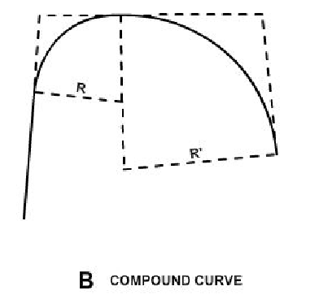

Fig 2.9: A typical compound curve

1. Reverse Curve: A reverse curve consists of two simple curves joined together but curving in opposite direction. It is highly recommended that this type of curve is avoided as much as possible for safety reasons as it poses accidental risk to drivers.

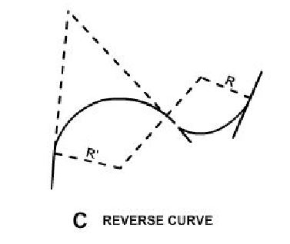

Fig 2.10: A Reverse Curve

1. Spiral curve: The spiral curve is a type of horizontal curve that has varying radius. It is mostly used for railroads and modern highways. It provides a transition from the tangent to a simple curve or between simple curves in a compound curve

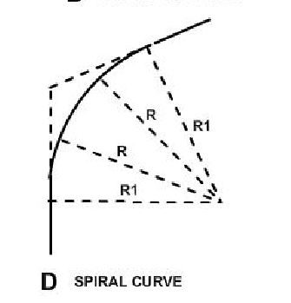

Fig 2.11: A spiral curve

ELEMENTS OF A HORIZONTAL CURVE

The element of a circular simple curve is shown in the figure below. Each element is further listed and explained.

1. POINT OF INTERSECTION (PI): The point of intersection is the point where the back and forward tangents intersect. In some instances, the point of intersection is taken as the vertex.
2. INTERSECTING ANGLE (I): The intersecting angle is the deflection angle at the PI. Its value is either computed from the preliminary traverse angles or measured in the field.
3. RADIUS (R): The radius is the distance from the center of a circle or curve represented as an arc, or segment. The radius is always perpendicular to back and forward tangents.

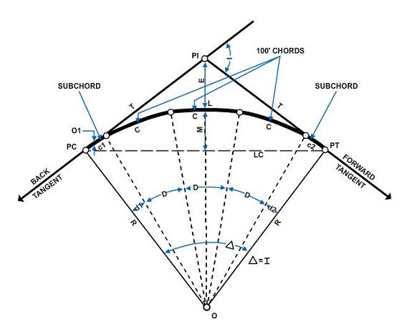

Fig 2.12: Elements of a horizontal curve.

1. POINT OF CURVATURE (PC): The point of curvature is the point on the back tangent where the circular curve begins. It is sometimes designated as BC (beginning of curve) or TC (tangent to curve).
2. POINT OF TANGENCY (PT): The point of tangency is the point on the forward tangent where the curve ends. It is sometimes designated as EC (end of curve) or CT (curve to tangent).
3. CENTRAL ANGLE (Δ): The central angle is the angle formed by two radii drawn from the center of the circle (O) to the PC and PT. The value of the central angle is equal to the I angle. It can also be called both the intersecting angle and central angle either I or A.
4. POINT OF CURVE (POC): The point of curve is any point along the curve.
5. LENGTH OF CURVE (L): The length of curve is the distance from the PC to the PT, measured along the curve.
6. TANGENT DISTANCE (T) The tangent distance is the distance along the tangents from the PI to the PC or the PT. These distances are equal on a simple curve.
7. LONG CHORD (LC) The long chord is the straight-line distance from the PC to the PT.

Other types of chords are designated as follows:

C The full-chord distance between adjacent stations (full, half, quarter, or one tenth stations) along a curve

C1 The sub chord distance between the PC and the first station on the curve

C2 The sub chord distance between the last station on the curve and the PT

1. EXTERNAL DISTANCE (E) The external distance (also called the external secant) is the distance from the PI to the midpoint of the curve. The external distance bisects the interior angle at the PI.
2. MIDDLE ORDINATE (M) The middle ordinate is the distance from the midpoint of the curve to the midpoint of the long chord. The extension of the middle ordinate bisects the central angle.
3. DEGREE OF CURVE (D) The degree of curve defines the sharpness or flatness of the curve. The degree of curve is further defined in two ways. The degree of curve can be defined either in terms of Arc or Chord
   * + ARC DEFINITION OF DEGREE OF CURVE:

This definition states that the degree of curve is the central angle formed by two radii that extend from the center of a circle to the ends of an arc measuring 100 feet long (or 100 meters long if you are using metric units). Therefore, if a sharp curve is taken, and a position is marked off so that the distance along the arc is exactly 100 feet, and the central angle is determined to be 12°, the degree of curvature is 12°. It is referred to as a 12° curve. This is usually used in highway design

* + - CHORD DEFINITION OF DEGREE OF CURVE

The chord definition is used in railway practice and in some highway work. This definition states that the degree of curve is the central angle formed by two radii drawn from the center of the circle to the ends of a chord 100 feet (or 100 meters) long.

If you take a flat curve, mark a 100-foot chord, and determine the central angle to be 0°30’, then you have a 30-minute curve (chord definition).

HORIZONTAL CURVE FORMULAS

1. Tangent Distance

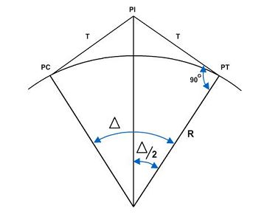

Fig 2.13: Tangent Distance

The tangent distance solution is a simple right triangle solution. In the figure, both T and R are sides of a right angle, with T being opposite to angle Δ/2. Therefore;

T= R tan (Δ/2)

1. Chord Distance

The solution for the length of a chord, either a full chord(C) or the long chord (LC), is also a simple right-triangle solution. As shown in the figure below, C/2 is one side of a right triangle and is opposite angle Δ/2. The radius (R) is the hypotenuse of the same triangle.

Therefore, sin (Δ/2) (C/2/R)

Solving for C:

C= 2R sin (Δ/2)

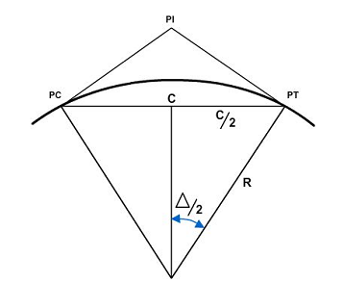

Fig 2.14: Chord distance

1. Length of Curve L = 100 (Δ/2)

## 2.6.4 VERTICAL ALIGNMENT

The Nigerian highway manual defines a vertical alignment as the longitudinal section of the road showing the gradients and the vertical curves. Once the horizontal alignment has been determined, the vertical alignment of the section of highway in question can be addressed. The vertical alignment is composed of a series of straight-line gradients connected by curves, normally parabolic in form. These vertical parabolic curves must therefore be provided at all changes in gradient. The curvature will be determined by the design speed, being sufficient to provide adequate driver comfort with appropriate stopping sight distances provided. The desirable maximum vertical gradients are shown in the table below.

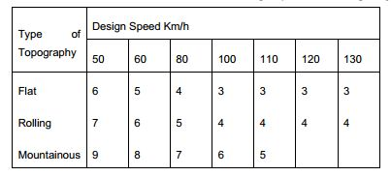

Table 2.6 : Table showing maximum grades to design speed for main highways.

VERTICAL CURVES.

As horizontal curves go right or left a road, vertical curves go up or down a road. Vertical curves connect stretches of road that go up or down at a constant slope. These lines of constant slope are called grade tangents. The rate of slope is called the gradient, or simply the grade. Grades that ascend in the direction of the stationing are referred to as plus while those that descend in the direction of the stationing are referred to as minus. Grades are measured in terms of percent, that is, the number of feet of rise or fall in a 100-foot horizontal stretch of the road.

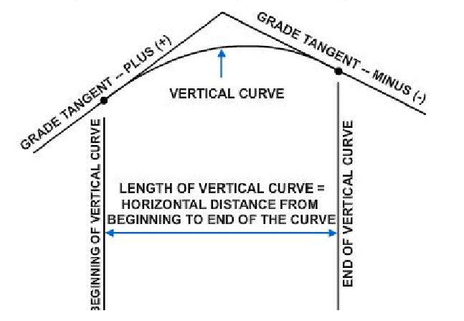

Fig 2.15: A Vertical Curve

K-VALUES OF A VERTICAL CURVE

The length of a vertical curve needed to meet the requirements of minimum sight distance comfortability and appearance should not be less than L=KA, where L is the length of the vertical curve and A is the algebraic difference of grades in percent. K is a constant related to design speed. The minimum values of K for vertical curves for varying are given in the table below.

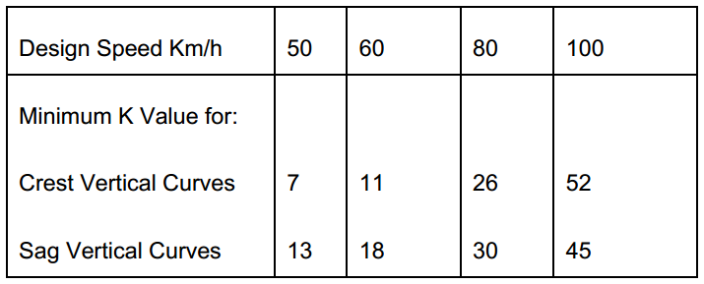

Table 2.15: Minimum K values for vertical curves as represented in the Nigeria Highway Manual.

After the location of a road has been determined and the necessary fieldwork has been obtained, the engineer designs set the grades. A number of factors are considered, including the intended use and importance of the road and the existing topography. If a road is too steep, the comfort and safety of the users and fuel consumption of the vehicles will be adversely affected; therefore, the design criteria will specify maximum grades. Typical maximum grades are a 4-percent desired maximum and a 6-percent absolute maximum for a primary road. For a secondary road or a major street, the maximum grades might be a 5-percent desired and an 8-percent absolute maximum, and for a tertiary road or a secondary street, an 8-percent desired and a 10-percent absolute maximum. Conditions may sometimes demand that grades or ramps, driveways, or short access streets go as high as 20 percent. The engineer must also consider minimum grades. A street with curb and gutter must have enough fall so that the storm water will drain to the inlets; 0.5 percent is a typical minimum grade for curb and gutter, that is, 1/2-foot minimum fall for each 100 feet ahead. For roads with side ditches, the desired minimum grade might be 1 percent, but since ditches may slope at a grade different from the pavement, a road may be designed with a zero-percent grade. Zero-percent grades are not unusual, particularly through plains or tidewater areas. Another factor considered in designing the finished profile of a road is the earthwork balance. The grades should be set so that all the soil cut off of the hills may be economically hauled to fill in the low areas.

ELEMENTS OF A VERTICAL CURVE:

The elements of a vertical curve are illustrated in the figure below and further explained.

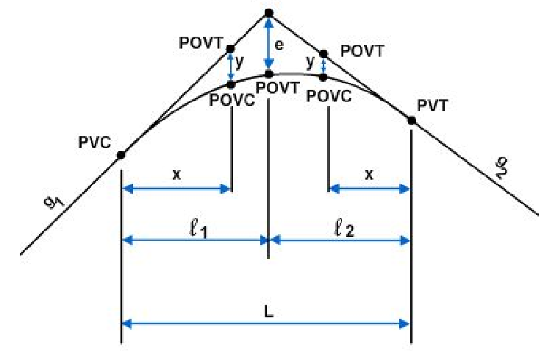 Fig 2.16: Elements of a vertical curve

The meaning of the symbols and the units of measurement usually assigned to them are explained below.

PVC - Point of vertical curvature is the point where the curve begins.

PVI - Point of vertical intersection is the point where the grade tangents intersect.

PVT - Point of vertical tangency is the point where the curve ends.

POVC - Point on vertical curve is the point which applies to any point on the parabola.

POVT - Point on vertical tangent is the point which applies to any point on either tangent.

g1 - Grade of the tangent on which the PVC is located. It is measured in percent of slope.

g2 - Grade of the tangent on which the PVT is located. It measured in percent of slope.

G-The algebraic difference of the grades:

G = g2 –g1

**Plus,** values are assigned to uphill grades and **minus** values are assigned to downhill grades. Some algebraic differences are shown below

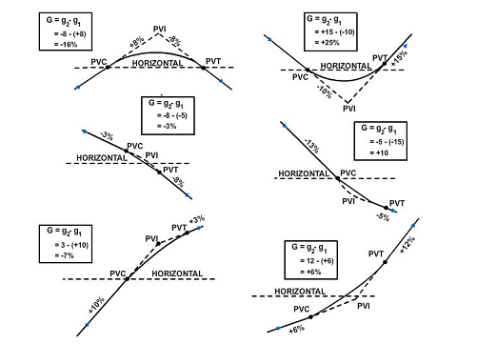

Fig 2.17: Algebraic Differences of grades.

L - Length of the curve; the horizontal length measured in 100-foot stations from the PVC to the PVT. This length may be computed using the formula L = G/r, where r is the rate of change (usually given in the design criteria). When the rate of change is not given, L (in stations) can be computed as follows: for a summit curve, L = 125 x G/4; for a sag curve, L = 100 x G/4. If L does not come out to a whole number of stations using these formulas, then it is usually extended to the nearest whole number. You should note that these formulas for length are for road design only.

L1 - Horizontal length of the portion of the PVC to the PVI; measured in feet.

L2 - Horizontal length of the portion of the curve from the PVI to the PVT; measured in

feet.

e - Vertical (external) distance from the PVI to the curve; measured in feet. This distance is computed using the formula e = LG/8, where L is the total length in stations and G is the algebraic difference of the grades in percent.

X - Horizontal distance from the PVC to any POVC or POVT back of the PVI, or the distance from the PVT to any POVC or POVT ahead of the PW; measured in feet.

y - Vertical distance (offset) from any POVT to the corresponding POVC; measured in

feet:

y = (x/l)2(e),

which is the fundamental relationship of the parabola that permits convenient calculation

of the vertical offsets.

The vertical curve computation takes place after the grades have been set and the curve designed. Therefore, at the beginning of the detailed computations, the following are known: g1, g2, l1, l2, L, and the elevation of the PVI. The general procedure is to compute the elevations of certain POVTs and then to use the foregoing formulas to compute G, then e, and then the Ys that correspond to the selected POVTs. When the y is added or subtracted from the elevation of the POVT, the result is the elevation of the POVC. The POVC is the finished elevation on the road, which is the end result being sought. The y is subtracted from the elevation of the POVT to get the elevation of the curve; however, in the case of a sag curve, the y is added to the POVT elevation to obtain the POVC elevation.

The computation of G requires careful attention to the signs of g1 and g2. Vertical curves are used at changes of grade other than at the top or bottom of a hill; for example, an uphill grade that intersects an even steeper uphill grade will be eased by a vertical curve. The six possible combinations of plus and minus grades, together with sample computations of G, are shown in Figure 3-16. Note that the algebraic sign for G indicates whether to add or subtract y from a POVT.

The selection of the points at which to compute the y and the elevations of the POVT and POVC is generally based on the stationing. The horizontal alignment of a road is often staked out on 50-foot or 100-foot stations. Customarily, the elevations are computed at these same points so that both horizontal and vertical information for construction will be provided at the same point. The PVC, PVI, and PVT are usually set at full stations or half stations.

# CHAPTER 3

## TECHNICAL EXPERIENCE

In line with the aims and objectives of SIWEs, I was able to gain several practical experiences which helped me to apply theoretical knowledge from the class room to real life practices.

I was exposed to the use of AUTOCAD for producing standard architectural drawings and also edit details of structural elements like slabs, beams and columns. I was also exposed to the use of software such as CSC Tedds and CSC Orion for the modelling, analysis and design of building structures. I was exposed on the use of Microsoft Excel to run some basic analysis especially commands to get beam loadings. I was partially involved in a traffic solution project where I was introduced to the concept of traffic surveys and analysis of various traffic problems and their solutions.

## 3.1 Reinforced Concrete design of a two storey Orion

The proposed building is a two storey building founded on a soil of bearing capacity 150KN/M2 using pad foundations. The architectural drawing was produced using AUTOCAD and the general arrangement of the structural members was also produced from the architectural drawing. Columns used got to the roof level supporting the roofing system. The dimension of column used is 225mm by 225mm. The beams used are 450mm and width is 225mm. All slabs where of 150mm deep and varies from two-way spanning slab to one-way spanning slab. As stated earlier, the soil bearing capacity is 150KN/mm2 with which pad foundations of depth 1200mm were used.

Structural analysis and design of sections of structural members were done using CSC Tedds. Modelling and design of the entire building was done using CSC Orion. Detail drawings were produced and exported to AUTOCAD for further editing. The process of design is illustrated below.

* + PLAN AND ELEVATION

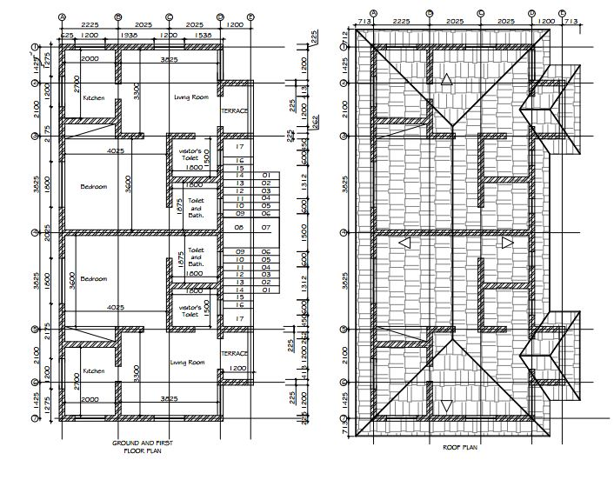

Fig 3.0: Ground and First floor plan alongside the roof plan.

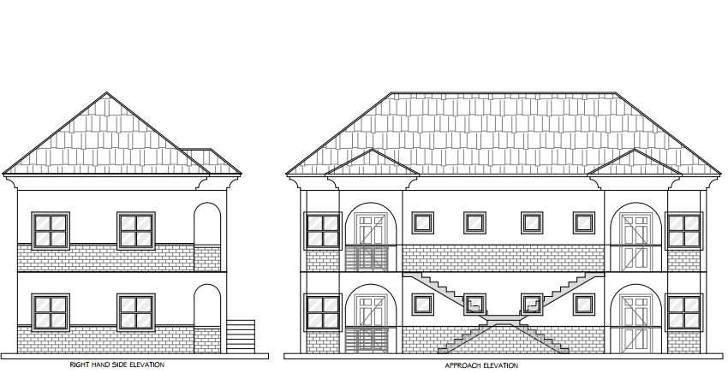

Fig 3.1**:** Approach elevation and Right hand side elevation.

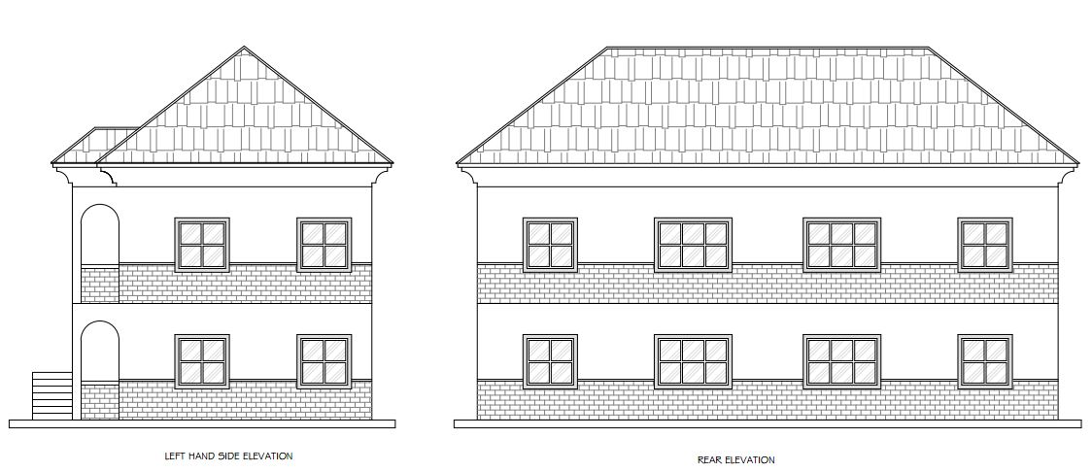

Fig 3.2: Rear elevation and left hand side elevation.

* GENERAL ARRANGEMENT

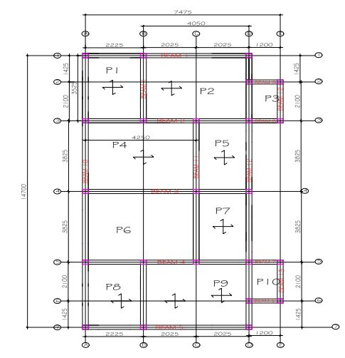

Fig 3.2: The General Arrangement of the building

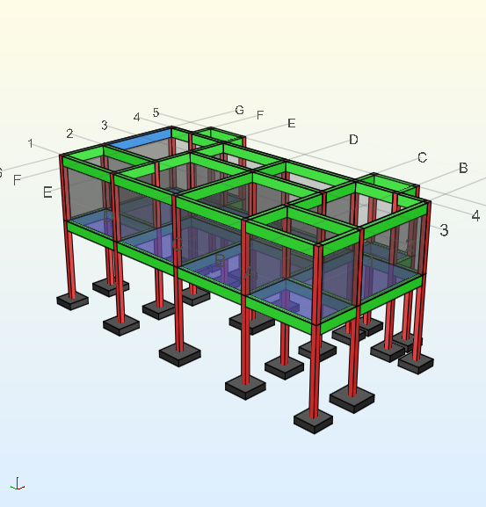

Fig 3.3: Figure showing Model of two storey building using Orion.

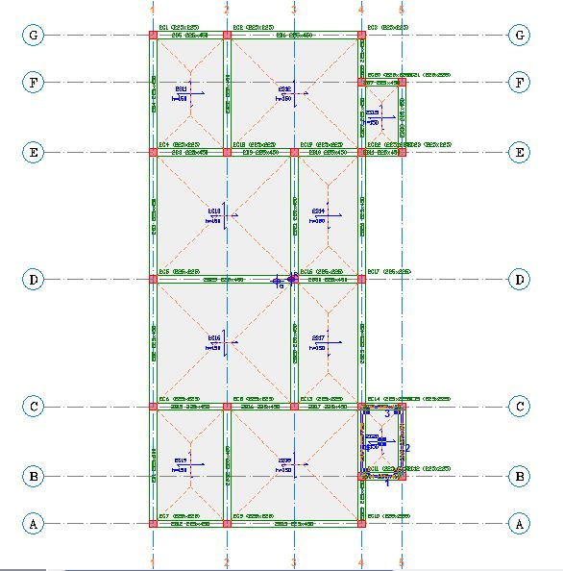

Fig 3.4:

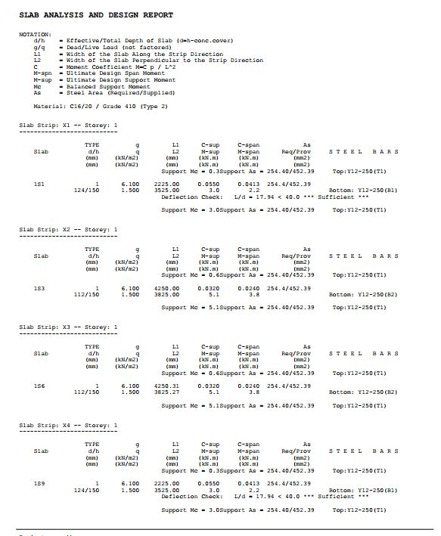

Fig 3.4: slab analysis report from Orion

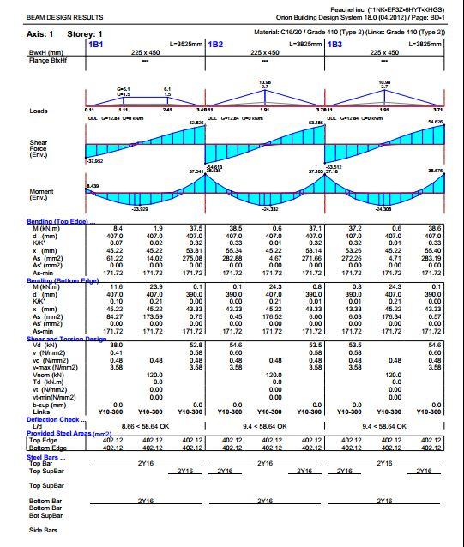

Fig 3.5: Beam Analysis Report from Orion

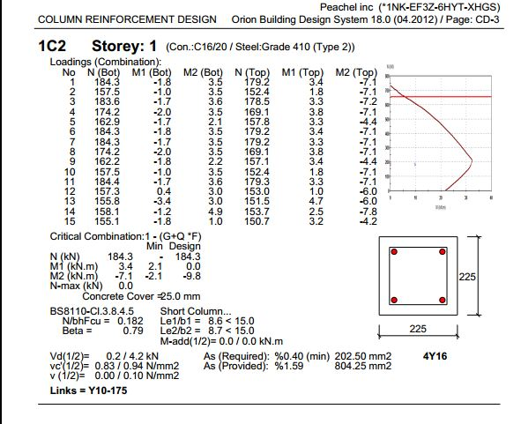

Fig 3.6: Column analysis report from Orion

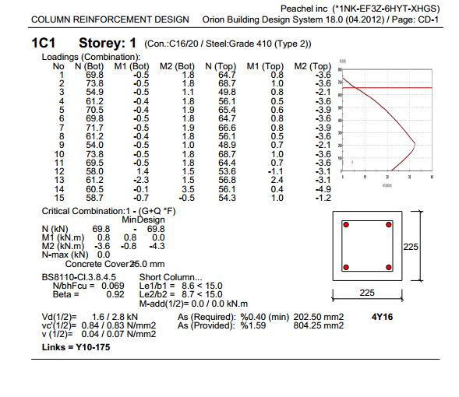

Fig 3.7: Column analysis report from Orion

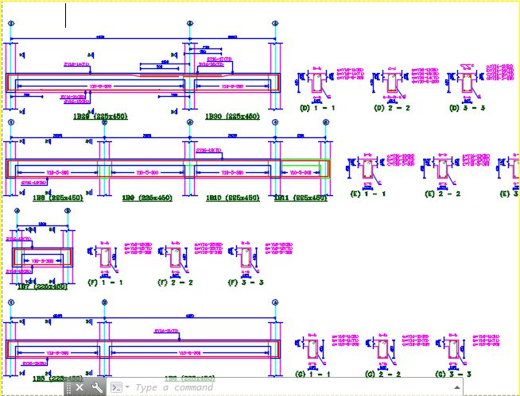

Fig 3.8: Beam detail drawing

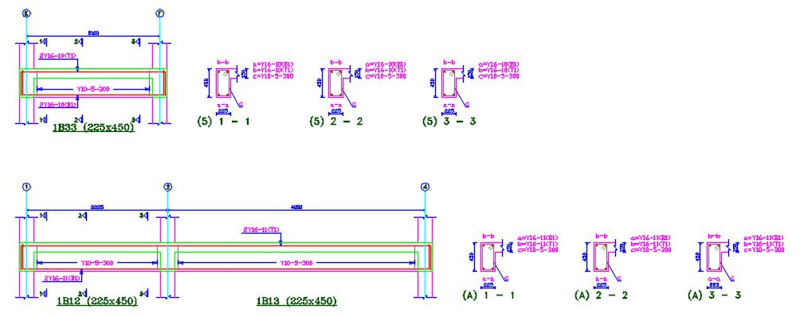

Fig 3.9: Beam detail drawing.

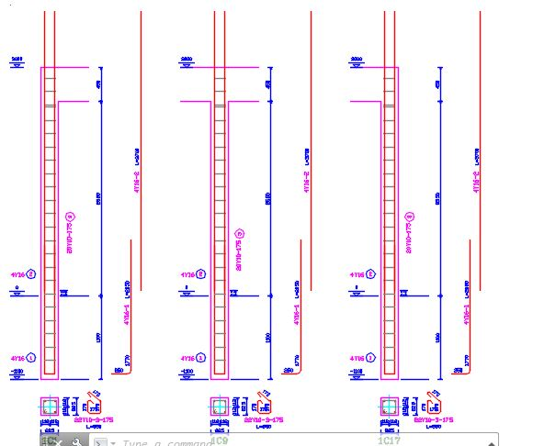

Fig 3.10: Column Detail Drawing

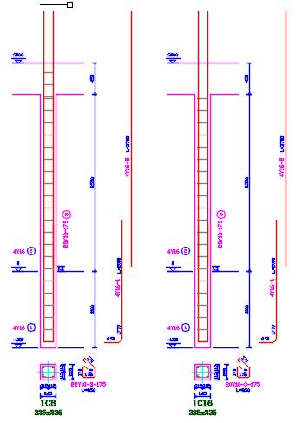

Fig 3.11: Column detail drawing.

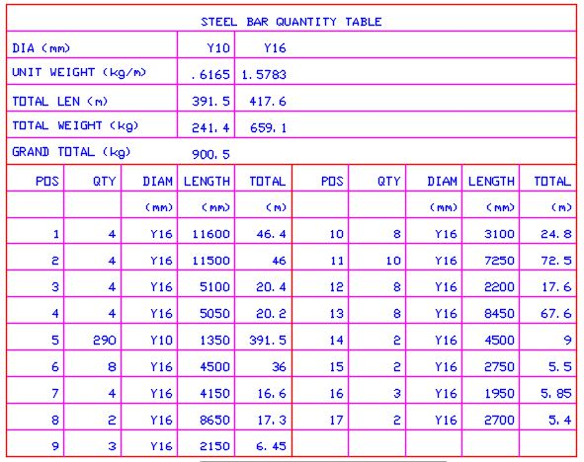

Fig 3.12: Steel Quantity Table

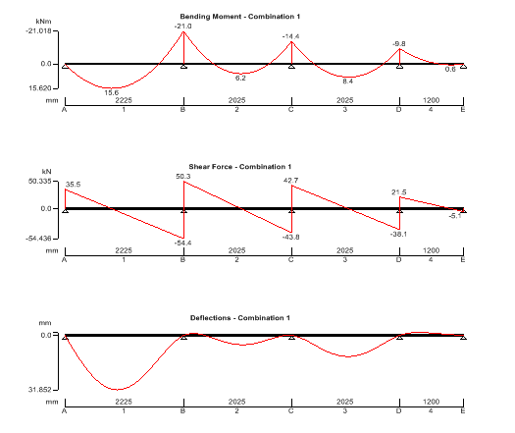

Fig 3.13: Beam Analysis result from CSC Tedds

**Staircase Design, Using CSC Tedds**

RC stair design (BS8110-1:1997)

TEDDS calculation version 1.0.03

Library item - Calculation title



Library item : Show stair section sketch

Stair geometry

Number of steps; Nsteps = **10**

Waist depth for stair flight; hspan = **200** mm

Going of each step; Going = **250** mm

Rise of each step; Rise = **175** mm

Angle of stairs; Rake = atan(Rise / Going) = **34.99** deg

Library item - Stair geometry

Upper landing geometry

Support condition; **Simply supported**

Landing length; Lupper = **1000** mm

Depth of landing; hupper = **200** mm

Library item - Landing geometry

Lower landing geometry

Support condition; **Simply supported**

Landing length; Llower = **1000** mm

Depth of landing; hlower = **200** mm

Library item - Landing geometry

Material details

Characteristic strength of concrete; fcu = **20** N/mm2

Characteristic strength of reinforcement; fy = **500** N/mm2

Nominal cover to reinforcement; cnom = **25** mm

Density of concrete; conc = **24.0** kN/m3

Library item - Material details

Partial safety factors

Partial safety factor for imposed loading; fq = **1.60**

Partial safety factor for dead loading; fg = **1.40**

Library item - Partial safety factors

Loading details

Characteristic imposed loading; qk = **3.000** kN/m2

Characteristic loading from finishes; gk_fin = **1.200** kN/m2

Average stair self weight; gk_swt = (hspan / Cos(Rake) + Rise / 2) × conc = **7.959** kN/m2

Design load; F = (gk_swt + gk_fin) × fg + qk × fq = **17.623** kN/m2

Library item - Loading details

Mid span design

Library item - Design titles

Midspan moment per metre width; Mspan = 0.125  F  L2 = **39.789** kNm/m

Diameter of tension reinforcement; span = **12** mm

Depth of reinforcement; dspan = hspan - cnom - span / 2 = **169** mm

Design formula for rectangular beams (cl 3.4.4.4)

Moment redistribution ratio; b = **1.00**

Kspan = Mspan / (dspan2 × fcu) = **0.070**

K’span = **0.156**

Kspan < K'span compression reinforcement is not required

Library item - Mid span K values

Lever arm; zspan = dspan × min([0.5 + √(0.25 - Kspan / 0.9)], 0.95) = **155** mm

Area of tension reinforcement required; As_span_req = Mspan / (0.87 × fy × zspan) = **591** mm2/m

Minimum area of tension reinforcement; As_span_min = 0.13  hspan / 100 = **260** mm2/m

Tension reinforcement provided; **12 dia.bars @ 150 centres**

Area of tension reinforcement provided; As_span_prov = **754** mm2/m

PASS - Tension reinforcement provided exceeds tension reinforcement required

Library item - Mid span design

Basic span/effective depth ratio (cl 3.4.6.3)

From BS8110 : Part 1 : 1997 – Table 3.9

Basic span/effective depth ratio; ratiobasic = **20.0**

Library item – Basic span/depth check

Modification of span/effective depth ratio for tension reinforcement (cl 3.4.6.5)

From BS8110 : Part 1 : 1997 – Table 3.10

Design service stress; fs = 2 × fy × As_span_req / (3 × As_span_prov × b) = **261.377** N/mm2

Modification factor for tension reinforcement; factortens = 0.55 + (477 N/mm2- fs)/(120 × (0.9 N/mm2+ (Mspan / dspan2)))

factortens = **1.334**

Check span/effective depth ratio (cl 3.4.6.1)

Allowable span/effective depth ratio; ratioadm = ratiobasic × factortens = **26.672**

Actual span/effective depth ratio; ratioact = L / dspan = **25.148**

PASS - Span/effective depth ratio is adequate

Library item – Span/depth check

Upper landing support design

Library item - Design titles

Diameter of tension reinforcement; upper = **12** mm

Depth of reinforcement; dupper = hupper - cnom - upper / 2 = **169** mm

Area of tension reinforcement required; As_upper_req = 0.4 × As_span_req = **236** mm2/m

Minimum area of tension reinforcement; As_upper_min = **260** mm2/m

Tension reinforcement provided; **12 dia.bars @ 200 centres**

Area of tension reinforcement provided; As_upper_prov = **565** mm2/m

PASS - Tension reinforcement provided exceeds tension reinforcement required

Library item - Upper landing simple design

Shear stress in beam (cl 3.4.5.2)

Design shear force; Vupper = 0.500 × F × L = **37.448** kN/m

Design shear stress; vupper = Vupper / dupper = **0.222** N/mm2

Allowable design shear stress; vmax = min(0.8N/mm2 × √(fcu / 1 N/mm2), 5 N/mm2) = **3.578** N/mm2

PASS - Design shear stress does not exceed allowable shear stress

From BS 8110:Part 1:1997 - Table 3.8

vc_upper = 0.79 N/mm2 × min(3, [100 × As_upper_prov / dupper]1/3) × max((400 mm / dupper)1/4, 0.67) × (min(fcu, 40 N/mm2) / 25 N/mm2)1/3 / 1.25

Design concrete shear stress; vc_upper = **0.505** N/mm2

PASS - Design shear stress does not exceed design concrete shear stress

Library item: Check upper shear stress

Lower landing support design

Library item - Design titles

Diameter of tension reinforcement; lower = **12** mm

Depth of reinforcement; dlower = hlower - cnom - lower / 2 = **169** mm

Area of tension reinforcement required; As_lower_req = 0.4 × As_span_req = **236** mm2/m

Minimum area of tension reinforcement; As_lower_min = **260** mm2/m

Tension reinforcement provided; **12 dia.bars @ 200 centres**

Area of tension reinforcement provided; As_lower_prov = **565** mm2/m

PASS - Tension reinforcement provided exceeds tension reinforcement required

Library item - Lower landing simple design

Shear stress in beam (cl 3.4.5.2)

Design shear force; Vlower = 0.500 × F × L = **37.448** kN/m

Design shear stress; vlower = Vlower / dlower = **0.222** N/mm2

Allowable design shear stress; vmax = min(0.8N/mm2 × √(fcu / 1 N/mm2), 5 N/mm2) = **3.578** N/mm2

PASS - Design shear stress does not exceed allowable shear stress

From BS 8110:Part 1:1997 - Table 3.8

vc_lower = 0.79 N/mm2 × min(3, [100 × As_lower_prov / dlower]1/3) × max((400 mm / dlower)1/4, 0.67) × (min(fcu, 40 N/mm2) / 25 N/mm2)1/3 / 1.25

Design concrete shear stress; vc_lower = **0.505** N/mm2

PASS - Design shear stress does not exceed design concrete shear stress

Library item: Check lower shear stress

# CHAPTER 4

## CHALLENGES ENCOUNTERED DURING SIWES

## 4.1 CHALLENGES ENCOUNTERED DURING THE PROGRAM.

This chapter of the report contains challenges encountered during the training period and ways in which I handled them.

1. **Lack of Site Exposure**

Except for a very few number of times that I was privileged to go to site for some light tasks, there was no opportunity for real site experience. This was mainly due to the fact that One of the two major projects being handled by the company was situated at Osun State. The project being a world bank project is the design and consulting services for the detailed engineering design, environmental and social assessment, procurement support, construction supervision and rehabilitation of 500km roads in Osun state. I was told that the company would not be able to sponsor any IT student to the project site for now as it is financially unstable and also the company recently received a horrible news of an IT student who they managed to post to the site who was involved in a ghastly accident which cost him his life while coming home during a weekend break. Due to this reason I wasn’t opportune to visit the project site. The other project being a Lagos state government project for the design and supervision of the reconstruction of the Lagos-Badagry Expressway project was out of reach due to the fact that the project was in a halt due to unavailability of funds.

This was the most challenging problem of all. I remedied this by trying to practice on drawing and designs that have been done on the project as also update myself with the level the project work is at.

1. **Monotony of Activities**

Due to the nature of the company i.e. consulting firm, various tasks are handed to more experienced professionals that are employed to execute the task. I will have to settle for little less relevant tasks to work on which I execute with to the best of my abilities. Along with the difficulty that the engineers rarely make use of manual designs, a knowledge which I really fancied to acquire during the period of my training.

This was one of the major challenges that looked unsolvable but with time I was able to win the trust of some engineers who tried as much as possible to incorporate me into some tasks, especially those that involve teams.

1. **Little Time for Interns**

Engineers working at Advanced Engineering Consultants are some very busy set of humans. Most of the time, engineers are usually bogged up with one work or another and the little time left to themselves, they utilize it on resting. This was a very huge challenge to me as it was really hard to get them to take me through some work aspects that seem tough.

I remedied for this by fostering a strong relationship with the engineers, and I was lucky that they would sometimes sacrifice their leisure time to help me through some difficult corners. Other times, I will have to wait after work hours late into the night.

# CHAPTER 5

## CONCLUSION AND RECOMMENDATIONS

## 5.1 CONCLUSION

I was able to put the experience garnered by me during the period of this SIWES program at Advanced Engineering Consultants in this report. The essence of gaining experience is one of the core reasons of establishing the SIWES program by the ITF as it is saddled with the responsibility of strengthening the effective teaching and learning of a skill based course such as civil engineering. The program upped my knowledge in the field of civil engineering as I was able to juxtapose the knowledge acquired in the classroom with real life experiences. The program also improved me psychologically as I was able to interact with people with different characters and behavioral patterns and learnt to work with them without our personalities serving as an obstacle. Finally, I was able to have a glimpse of a real working class environment. I therefore can conclude that the program is of a really great benefit to students in tertiary institutions across Nigeria. If the program can further be improved upon in terms of proper and effective administration, it will serve as a major boost in enhancing the already questionable capacities of workforce in the country.

## 5.2 RECOMMENDATIONS

In view of the relevance of the SIWES program, it is important that it is sustained by

the government through the Industrial Training Fund (ITF) as it exposes student to work tools,

facilities and equipment that may not be available in respective institutions in relation to course of study.

I recommend that the following under-listed points can be implemented to ensure the further impact of the SIWES program:

* It has always been a problem for students to locate a suitable place for their industrial attachment. My recommendation is that Provision should be made for students going on this Industrial attachment to fix them in industries relevant to their course of study
* The department can liaise with various civil engineering companies to obtain designated placements for the I.T students of the departments; as securing industrial placement by the students all by themselves usually results to hostile or non-productive responses from such companies.
* The department can invite Organizations representative to a round table meeting to discuss the essence of the program to the students and how they can help make the scheme more effective.
* Organizations should always accept students for SIWES and subsequently assign them to relevant jobs as this can also be their quota in nation building.
* The government should fund the scheme more, to make it more effective and a large number of Nigerian students can enjoy the benefits equally.
* The department can organize seminars before the commencement of the SIWES program to orientate them on what is expected of them from the program and how they can make the best out of the program



Plate 5.0: Intern Using the theodolite on site



Plate 5.1: Intern Learning the Operation of theodolite from the Surveyors



Fig 5.3: Intern Holding the Reflector during Survey



Fig 5.4: Intern on Site at Bariga Lagos State.

## REFERENCES

Chanakya Arya (2009). Design of Structural Elements, Taylor and Series, USA.

COREN (1991). Supervised Industrial Training Scheme in Engineering (SITSIE). Council of Registered Engineers of Nigeria.

Duggal S.K (2008). Building Materials 3rd Edition, New age International Limited Publishers, New Delhi India.

Ekpenyong, L.E. (2011). Foundations of Technical and Vocational Education: Evolution and Practice for Nigerian Students in TVE and Adult Education, Policy Makers and Practitioners.

Igba, T.U (2017). Design of Structures I (CVE 306); Unpublished Lecture Note, Department of Civil Engineering, Federal University of Agriculture Abeokuta.

Mosley W.H and Bungey (1987). Reinforced Concrete Design Third Edition; Macmillan Education Limited

Oyenuga, V. O (2008). Simplified Reinforced Concrete Design, 2nd ed. Asross Limited, Lagos.

Structural Use of Concrete. Part 1: Code of Practice for Design and Construction. BS 8110. (1985). London: BSI.

Reynolds, C.E and Steedman J.C (1999). Reinforced Concrete Designer’s Handbook, Tenth Edition. E & FN Spon Publishers

http://www.smweng.com/smw-civil-engineering-defined

https://www.brighthubengineering.com/building-construction-design/41552-history-of-civil-engineering/

http://www.civilengineeringbible.com

http://www.thecivilengg.com/History.php

https://www.engineeringcivil.com/history

https://www.careeraddict.com/top-10-skills-needed-for-a-job-in-civil-engineering

https://www.aboutcivil.com/concrete-technology,2008.